`

Project Guided By: Mr Uday Shah



A Project Submitted to

Noble University

Faculty Of MCA

Project Report on



Project Developed By:

Sohil Vora - 220441025

Zaid Vora - 220441024

2024





**PREFACE**

There is a wide difference between theory and practical. If one has only theoretical background of any subject, one would not succeed in own aim therefore it is necessary for any person to have adequate practical knowledge of the concerned subject. As I know MCA is a course based on “Information Technology” and it is totally practical field. With only theoretical knowledge one can’t be succeeded or one can’t be on the peak position.

In the course of MCA designed by the “Noble University” they have taken full care of these things and designed the course in such a manner with which student can get theoretical and practical both type of knowledge perfectly. According to the rules & regulation of “Web Development”, we have a subject named “INDUSTRIAL TRAINING”. In which we have to create a web project of any institute or industry.

As a MCA student, I have gathered general information about E-Commerce Site. Then I decided to develop the site for Ecommerce site for shopping. In this site you can you can buy many new product as well as you can return the product as per company police. You can also put the advertisement on this site.

In this project report I have covered all the information, which is required for the web project of MCA student.

I have tried as my best present this project report in such a way that it makes easy to understand the project work.

**ACKNOWLEDGEMENT**

Much happy to present this “Project Report”. Before you, expecting that you will acknowledgement it. It is a matter of great pleasure for me that I had an opportunity to express our view on the same.

As a part of our academic study as the student of 4th semester of MCA I am required to undergone training software project an institute or industry in order to obtain practical knowledge and broaden our regarding the same.

At first, I would like to express our & humble thanks & gratitude to the who has provided us such a great, Co- operative & progressive environment.

Secondly at this moment, I would like to express our deepest sense of gratitude to our professor as well as project guides “Mr Uday Shah” and who have contributed their precious time for the purpose of giving us the correct information with special interest & guidance throughout our project work.

I am also thankful to our classmate and few others who helped me directly or indirectly in solving problem & in making our software project more efficient & good working.

**INDEX**

|  |  |  |
| --- | --- | --- |
| Serial no. | Title | Page no. |
| 1. | **Introduction and objective of project** | 1 – 10 |
| 1.1 | Existing System | 2 |
| 1.2 | Need for the New System | 3 |
| 1.3 | Objective of the New System | 4 |
| 1.4 | Problem Definition | 5 |
| 1.5 | Core Components | 6 |
| 1.6 | Project Profile | 7 |
| 1.7 | Assumptions and Constraints | 9 |
| 1.8 | Advantages and Limitations of the Proposed System | 10 |
|  | | |
| 2. | **Requirement Determination & Analysis** | 11 - 12 |
| 2.1 | Requirement Determination | 11 |
| 2.2 | Targeted Users | 12 |
|  | | |
| 3. | **System Design** | 13 - 22 |
| 3.1 | Use Case Diagram | 13 |
| 3.2 | Class Diagram | 17 |
| 3.3 | Interaction Diagram | 18 |
| 3.4 | Activity Diagram | 19 |
| 3.5 | Data Dictionary | 20 |
|  | | |
| 4. | **Development** | 23 - 39 |
| 4.1 | Coding Standards | 23 |
| 4.2 | Screen Shots | 26 |
|  | | |
| 5. | **Agile Documentation** | 40 - 52 |
| 5.1 | Agile Project Charter | 40 |
| 5.2 | Agile Roadmap / Schedule | 42 |
| 5.3 | Agile Project Plan | 44 |
| 5.4 | Agile User Story (Minimum 3 Tasks) | 46 |
| 5.5 | Agile Release Plan | 47 |
| 5.6 | Agile Sprint Backlog | 49 |
| 5.7 | Agile Test Plan | 50 |
| 5.8 | Earned-value and burn charts | 52 |
|  | | |
| 6. | **Proposed Enhancements** | 53 - 54 |
|  | | |
| 7. | **Conclusion** | 55 |
|  |  |  |
| 8. | Bibliography | 56 |

**Chapter – 1 Introduction And Objective Project**

1.1. Existing System

1.2. Need for the New System

1.3. Objective of the New System

1.4. Problem Definition

1.5. Core Components

1.6. Project Profile

1.7. Assumptions and Constraints

1.8. Advantages and Limitations of the Proposed System

Introduction

The E Mart System is design & developed for to manage their records for selling and purchasing of the Electronic goods from dealers and sell them to the customers. This system make the work of the electric shopkeepers easy as keep all the records of the electric product and also keep the record of the product that sold by customers. In this project we can easily maintain system sales details.

The E Mart project is a multi-user system. It has been developed in a way that allows user to perform the function smoothly. The system is developed in PHP-MySql and some other software used. The system maintains the data of the electric goods And provides a best product to buy.

The report of this system is important. It provides information about the ‘E Mart. Hence our system gives the complete information of the ‘electric item’ at a glance.

This system is prepared in order to give all the information about electronic items and also for getting of the whole specifications. Our system also contains the data storage like user information, Electronic item information and also brands of the Electronic Items.

1.1 Existing System

Here's a summary of an electronic shop's operations without the use of Ecommerce Platform:

* **Overview:** An electronic shop without the use of ecommerce plate form operates through traditional, manual methods for selling electronic products. The shop relies on in-person transactions, paper-based records, and face-to-face customer service.
* **Product Display:** Electronic products are displayed on shelves or tables in the shop, allowing customers to browse the available items in person.
* **Inventory Management:** Inventory is tracked manually, often using written records or physical counts.
* **Sales Transactions:** Sales are completed in person at a cash register, where customers pay using cash, checks, or possibly credit cards if a manual imprinting machine is available.
* **Order Management:** Orders may be taken in person or over the phone and recorded on paper. Fulfilment is handled manually, including picking items from the shelves and coordinating shipping if necessary.
* **Record Keeping:** Transactions and customer information are recorded on paper, such as sales receipts, invoices, and other documentation.
* **Physical Interaction:** Customers can physically examine products and ask questions in person before making a purchase.
* **Limitations and Challenges:**
* **Lack of Efficiency:** Manual record keeping and inventory management can be time-consuming and prone to human error.
* **Limited Reach:** Without an online presence, the shop's customer base is limited to those who visit the physical store.
* **Inconvenient Transactions:** Without digital payment systems, transactions may be slower and less flexible.
* **Challenges in Scalability:** Scaling up the business is challenging without computerized systems to streamline operations.

In summary, an electronic shop without ecommerce platform operates using manual, traditional methods for all aspects of its business, from sales and inventory management to customer service. This approach can offer personalized service but may face challenges in efficiency, scalability, and customer convenience.

1.2 Need for the New System

Here's a summary of the need for the new system for an electronic shop's e-commerce platform:

* **Overview:** The existing system is a web-based platform for the electronic shop that enables customers to browse and purchase electronic products online. It supports essential e-commerce features, including a product catelog, shopping cart, and checkout process.
* **Current Features and Functionalities:**
* **Product Catalog:** The system provides a digital catalog for customers to browse electronic products. It includes product descriptions, images, prices, and inventory information.
* **Search and Filtering:** Customers can search for specific products using keywords or categories and apply filters to narrow down options.
* **Shopping Cart and Checkout:** Customers can add products to a virtual cart and proceed through a checkout process, entering payment and shipping information.
* **Payment Processing:** The system integrates with a payment gateway to enable secure online transactions via credit/debit cards and other methods.
* **Order Management:** Once orders are placed, the system manages order tracking, updates, and fulfilment.
* **Customer Accounts:** Customers can create accounts to manage their orders, view order history, and save shipping and payment preferences.
* **Limitations and Challenges:**
* **Outdated Technology:** The system may be using outdated technology, affecting performance and scalability.
* **Limited User Experience:** The interface may be less user-friendly, lacking modern design and responsive elements for mobile devices.
* **Security Concerns:** There may be potential security vulnerabilities or data protection issues.
* **Inflexible Payment Options:** Limited payment methods and lack of integration with new payment gateways.
* **Lack of Advanced Features:** Missing advanced features such as personalized recommendations, advanced search options, and marketing tools.
* **User Feedback:** Customers may have provided feedback about slow page loading times, limited mobile compatibility, and difficulties with finding products or completing transactions.

This summary outlines the existing e-commerce system for the electronic shop, highlighting its features, strengths, and limitations. Understanding these aspects helps identify areas for improvement and the need for a new or updated system.

1.3 Objective of the New System

Here's a summary of the objective of the new e-commerce system for an electronic shop:

* **Enhanced User Experience:** The new system aims to provide a more intuitive and seamless shopping experience for customers. This includes a modern user interface, responsive design for mobile devices, and advanced search and filtering capabilities.
* **Improved Performance and Reliability:** The system will enhance performance through faster load times and more consistent uptime, ensuring customers can access the shop and complete transactions without interruptions.
* **Advanced Features and Functionalities:** The new system will offer a wider range of features such as personalized recommendations, targeted marketing tools, and a more efficient checkout process. This includes omnichannel capabilities for a consistent experience across multiple touchpoints.
* **Enhanced Security and Privacy:** Improved security measures, such as encryption and data protection protocols, will safeguard customer information and transactions. Compliance with privacy regulations will also be prioritized.
* **Diverse and Flexible Payment Options:** The new system will integrate with multiple payment gateways to offer customers a variety of payment methods, including digital wallets and alternative payment options.
* **Streamlined Order Management:** Order processing will be more efficient, including automated inventory management and real-time order tracking, resulting in faster and more accurate fulfilment.
* **Better Customer Support:** Improved customer support channels, such as live chat and comprehensive help centers, will enhance the overall shopping experience and address customer inquiries more effectively.
* **Analytics and Insights:** The system will collect and analyze data on customer behavior, sales, and other metrics to provide actionable insights for improving business strategies and operations.
* **Scalability and Flexibility:** The new system will be designed to accommodate business growth and adapt to changing market conditions, ensuring the shop remains competitive and can scale as needed.

In summary, the objective of the new e-commerce system is to enhance the electronic shop's operations by improving the user experience, performance, security, and operational efficiency. By offering advanced features and better support, the new system aims to increase customer satisfaction, loyalty, and sales while positioning the shop for long-term success.

1.4 Problem Definition

Here is a summary of the problem definition for an electronic shop's existing e-commerce system:

* **Outdated Technology:** The existing e-commerce system relies on outdated technology, which leads to various performance issues, including slow load times and occasional system crashes. This can negatively impact customer satisfaction and overall sales.
* **Limited Features and Functionalities:** The current system may lack modern e-commerce features such as advanced search options, personalized recommendations, and targeted marketing tools. This limits the shop's ability to provide a seamless and engaging shopping experience for customers.
* **Poor User Experience:** The user interface of the existing system may be cumbersome, outdated, or not optimized for mobile devices. This can make it difficult for customers to navigate the site, find products, and complete purchases.
* **Inflexible Payment Options:** The existing system may offer a limited range of payment options, which can inconvenience customers and lead to abandoned carts and lost sales.
* **Inefficient Order Management:** Manual or inefficient order management processes can result in delays, errors, and dissatisfied customers. The existing system may lack automation for order processing, inventory management, and tracking.
* **Challenges with Scalability:** The existing system may struggle to handle increased transaction volumes and business growth. This can hinder the shop's ability to expand and meet changing market demands.
* **User Feedback:** Feedback from customers may highlight issues such as difficulty finding products, completing purchases, and navigating the site. Negative customer experiences can lead to reduced customer loyalty and retention.

In summary, the existing e-commerce system for the electronic shop faces several challenges, including outdated technology, limited features, poor user experience, and security concerns. These issues affect the shop's ability to provide a seamless shopping experience, efficiently manage operations, and scale to meet future growth. Addressing these problems is essential for the shop's success and competitiveness in the e-commerce market.

1.5 Core Components

In e-commerce, core components are the essential parts that make up an online retail business and facilitate its smooth operation. These components are critical for providing a seamless shopping experience for customers. The core components of an e-commerce business typically include:

* **Website and User Interface:** A user-friendly website with an intuitive design is the foundation of an e-commerce business. It includes product listings, search and filter options, and a clear and efficient checkout process.
* **Product Catalog and Management:** A comprehensive product catalog with up-to-date information on items, such as descriptions, images, pricing, and availability. Product management includes the organization and categorization of products for easy browsing.
* **Shopping Cart and Checkout:** A functional and secure shopping cart allows customers to select products and proceed to checkout with ease. The checkout process should be streamlined, offering multiple payment options and delivery choices.
* **Payment Processing:** Secure and reliable payment gateways are essential for processing transactions safely. They should support multiple payment methods, including credit/debit cards, digital wallets, and alternative payment options.
* **Order Management and Fulfillment:** Efficient order management ensures smooth processing of customer orders, including order tracking, packing, shipping, and delivery.
* **Customer Service and Support:** Providing responsive and helpful customer service through multiple channels (e.g.,email, phone) is essential for addressing customer inquiries and resolving issues.

These core components work together to create a seamless e-commerce experience for customers and support efficient business operations for the company.

1.6 Project Profile

* **Project Name:** E-Mart Online Store for Enhanced Customer Experience
* **Project Description:** This project aims to improve the customer experience on the online store by redesigning the website interface, streamlining the checkout process, and implementing personalized product recommendations. These enhancements are expected to increase sales, reduce cart abandonment, and improve customer loyalty.
* **Scope of Work:**
* Redesign the website for a more modern and user-friendly interface.
* Optimize website navigation and search functionality for better user experience.
* Streamline the checkout process for faster and simpler transactions.
* Integrate personalized product recommendations on the website.
* Test all new features for usability and performance.
* Launch the updated website and provide support for the transition.
* **Timeline and Milestones:**
* Phase 1: Planning and Design
* Develop project plan and design new website interface.
* Milestone: Complete website design
* Phase 2: Development and Integration
* Implement new features such as product recommendations and checkout enhancements.
* Milestone: Complete development and start testing.
* Phase 3: Testing and Quality Assurance
* Test new features for performance and usability.
* Milestone: Complete testing and receive sign-off.
* Budget and Resource Allocation:

Working time estimation is as given,

2 months + 05 days / month = 65 days

5 hour / day = 340 hours

Now, the expenses & cost estimation are given below :

Computer rent = 5,000 /-

+ Light Bill Rs. 8.50 / unit

Worth 200 units = 1,700 /-

+ Database design & creation = 2,500 /-

+ Coding & Validation = 3,000 /-

Amount = 12,200 /-

- Late Discount = 200 /-

Total = 12,000 /-

* Deliverables:
* Redesigned and optimized website.
* Streamlined checkout process.
* Personalized product recommendation system.
* User testing and feedback reports.
* Dependencies and Constraints:
  + - * Dependency on third-party software for payment processing and recommendations.
      * Regulatory compliance for data protection and online sales.

This project profile provides a comprehensive overview of the goals, timeline, resources, and strategies for a successful e-commerce project.

1.7 Assumptions and Constraints

In e-commerce projects, assumptions and constraints are important considerations that can influence the project's planning, execution, and outcomes. They help define the project's context and establish the parameters within which the project operates. Here's a summary of each:

* **Assumptions**:
* Assumptions are statements or conditions believed to be true for the project's success. They are not guaranteed, but are expected to hold true based on experience or data. Common assumptions in e-commerce projects include:
* **Customer Behavior**: Assumption that customers will respond positively to the planned changes, such as a redesigned website or new features.
* **Technology**: Assumption that the technology used (e.g., e-commerce platform, payment gateways) will perform as expected and support the project goals.
* **Market Conditions**: Assumption that the market conditions (e.g., economic factors, competition) will remain stable or predictable during the project.
* **Resource Availability**: Assumption that the necessary resources (e.g., personnel, budget, third-party services) will be available as planned.
* **Constraints**:
* Constraints are limitations or restrictions that can impact the project and need to be managed. They can come from various sources and may require careful planning to mitigate. Common constraints in e-commerce projects include:
* **Budget**: Financial limitations that dictate how much can be spent on different aspects of the project.
* **Time**: Project deadlines and timelines that restrict the duration and scheduling of tasks and activities.
* **Technology**: Limitations imposed by the technology in use, such as compatibility issues, performance limits, or software dependencies.
* **Regulations**: Legal and regulatory requirements that must be adhered to, such as data privacy laws and e-commerce regulations.
* **Resource Availability**: Availability of personnel, expertise, and third-party services, which may be limited and affect the project's execution.

Both assumptions and constraints should be clearly identified and documented at the beginning of the project. This allows the project team to plan effectively and develop strategies to address potential risks or challenges that may arise from these factors. Regularly revisiting and reassessing assumptions and constraints throughout the project can help ensure the project remains on track.

1.8 Advantages and Limitations of the Proposed System

In an e-commerce project, the proposed system refers to the new or upgraded platform, features, or processes that the project aims to implement. Here is a summary of the advantages and limitations of the proposed system:

* **Advantages:**
* Enhanced User Experience: A redesigned website or new features can improve navigation, search, and checkout processes, leading to a better customer experience.
* Increased Sales and Revenue: Improved user experience, product recommendations, and streamlined checkout can boost sales and increase revenue.
* Personalization and Customer Loyalty: Implementing personalized product recommendations and targeted marketing can help retain customers and foster loyalty.
* Scalability: A modern e-commerce platform can support business growth and expansion by accommodating increased traffic and transaction volumes.
* Efficiency and Cost Savings: Automation and streamlined processes can increase operational efficiency and reduce costs related to manual tasks and errors.
* Competitive Edge: Adopting new technologies and features can help the business stay competitive in the market and meet evolving customer expectations.
* **Limitations:**
* Implementation Challenges: Integrating new systems and features may require significant time, effort, and technical expertise.
* Cost: Initial setup and maintenance costs for new features or platforms can be high, impacting the project's budget.
* Compatibility Issues: There may be compatibility challenges with existing systems or third-party services, which can complicate implementation.
* Change Management: Introducing new systems may require training for employees and adjustments for customers, which can slow down adoption.
* Security Risks: Adding new features or modifying existing systems can introduce security vulnerabilities that need to be addressed.
* Performance Concerns: New features or changes to the website may impact site speed or performance, potentially affecting user experience.

**Chapter – 2 Requirement Determination & Analysis**

2.1 Requirement Determination

2.2 Targeted Users

2.1 Requirement Determination

* Title : E Mart
* Hardware Requirements

Processor : I3 or higher

Ram : 4 GB(Minimum)

Hard Disk : 120 GB (Minimum)

* Tools Used

Front End : HTML, CSS, JS, BootStrap,

Ajax, jQuery

Back End : PHP, MYSQL

Operating System : Windows 8 or Higher

* Software Requirement

Xampp/Wampp Server

Google Chrome

VS Code or other code editor

2.2 Targeted Users

* **Demographics:** Understanding the age, gender, and geographic location of the targeted users.
* **Psychographics:** Identifying the lifestyle, interests, values, attitudes, and purchasing behavior of the users.
* **Needs and Pain Points:** Understanding the specific needs, desires, and challenges faced by the targeted users when shopping online.
* **Buying Behavior:** Analyzing users' buying patterns, such as frequency of purchases, preferred product categories, and average order values.
* **User Preferences:** Identifying users' preferences regarding website design, navigation, search and filter options, payment methods, and delivery choices.
* **Feedback and Reviews:** Collecting and analyzing user feedback, reviews, and ratings to gain insights into user satisfaction and areas for improvement.
* **User Personas:** Creating detailed user personas that represent different segments of the target audience, helping the project team better understand user needs.
* **Trends and Insights:** Staying informed about market trends, emerging technologies, and changing customer preferences to anticipate and adapt to users' evolving needs.

By focusing on the targeted users, e-commerce projects can design and implement features, strategies, and experiences that resonate with the intended audience. This user-centric approach can lead to higher customer satisfaction, loyalty, and overall success for the business.

**Chapter – 3 System Design**

3.1. Use Case Diagram

3.2. Class Diagram

3.3. Interaction Diagram

3.4. Activity Diagram

3.5. Data Dictionary

3.1 Use Case Diagram

A use case diagram is a type of UML (Unified Modeling Language) diagram that represents the functional requirements of a system in terms of how users (or actors) interact with the system to achieve specific goals (or use cases). It provides a high-level view of what the system does without getting into the details of how it does it. In other words, use case diagrams are a visual way to describe the interactions between a system and its external entities.

Here are the main components of a use case diagram:

* **Actors:** These are the external entities (people, systems, or other entities) that interact with the system. Actors are typically depicted as stick figures and can represent users, other systems, or even hardware devices.
* **Use Cases:** Use cases represent the different functions or activities that the system can perform. Each use case is typically depicted as an oval and describes a specific goal or task the actor wants to accomplish with the system.

Here are Diagram of a use case diagram:

* **Visitor Use Case Diagram:**



**Home**

**Register**

**Login**

**Contact Us**

**About Us**

**Shop**

**Shop by Category**

**Visitor**

* **User Use Case Diagram:**



**Logout**

**Feedback**

**User**

**My Cart**

**Home**

**My Order**

**My Profile**

**Contact Us**

**About Us**

* **Admin Use Case Diagram:**



**Logout**

**Admin**

**Message**

**Orders**

**Brand**

**Category**

**Product**

**User**

**Dashboard**

3.2 Class Diagram

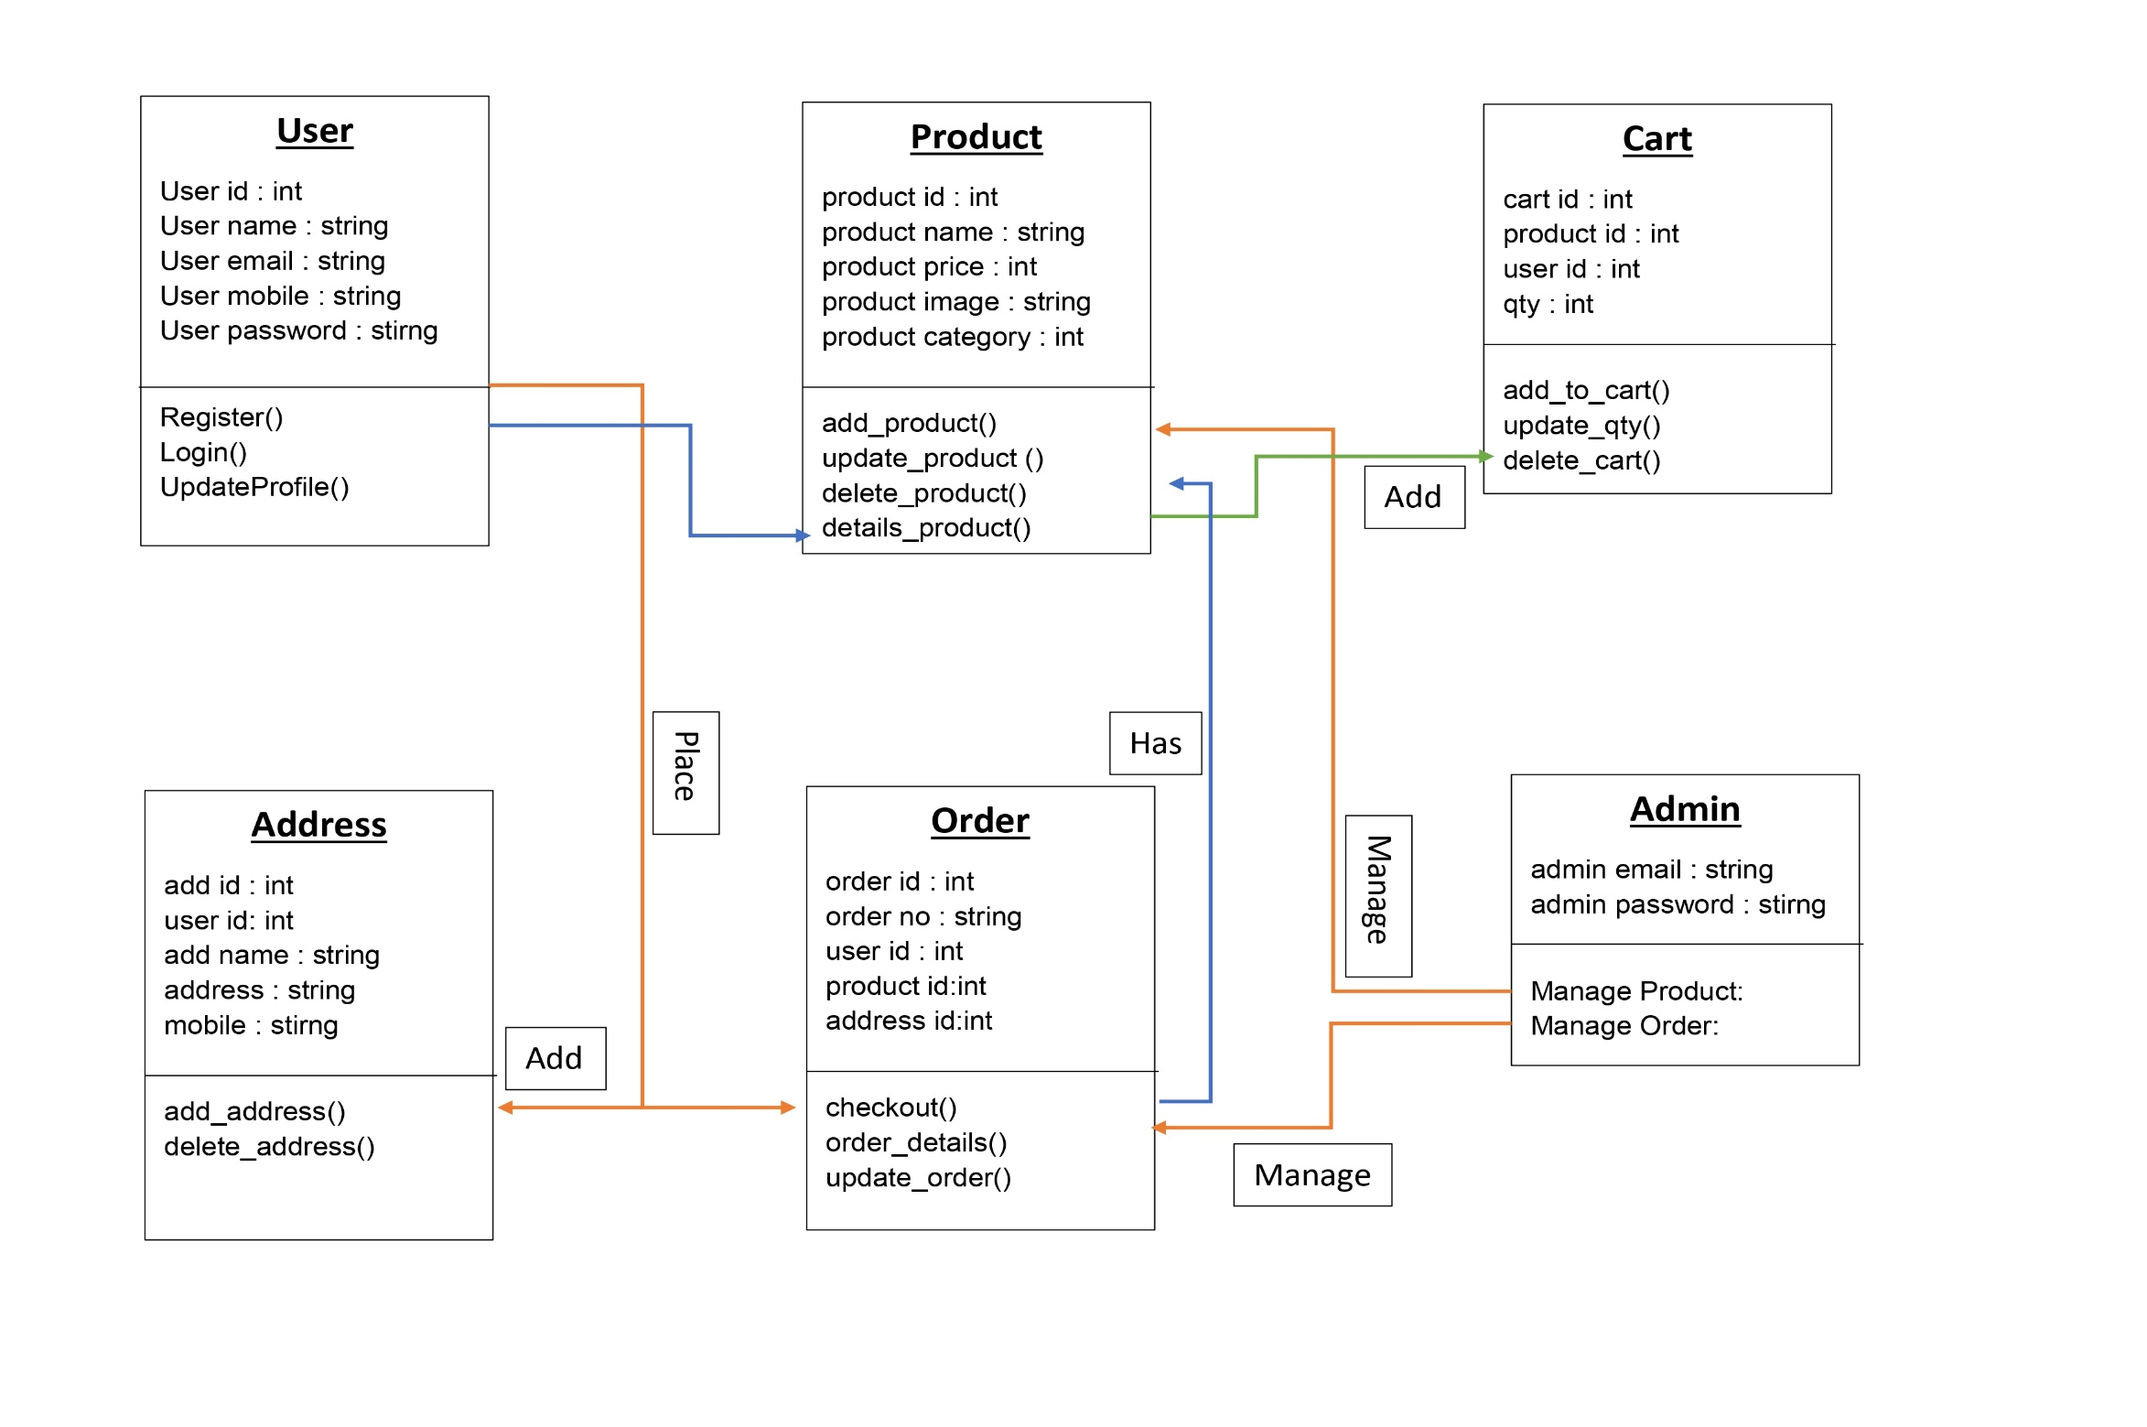

3.3 Interaction Diagram

In the context of an e-commerce project, an interaction diagram refers to a type of diagram that depicts the interactions and relationships between different components, actors, and systems within the e-commerce environment. This type of diagram can help you understand the flow of information and how different parts of the system work together to provide services and manage processes such as purchasing, payments, inventory management, and customer interactions.

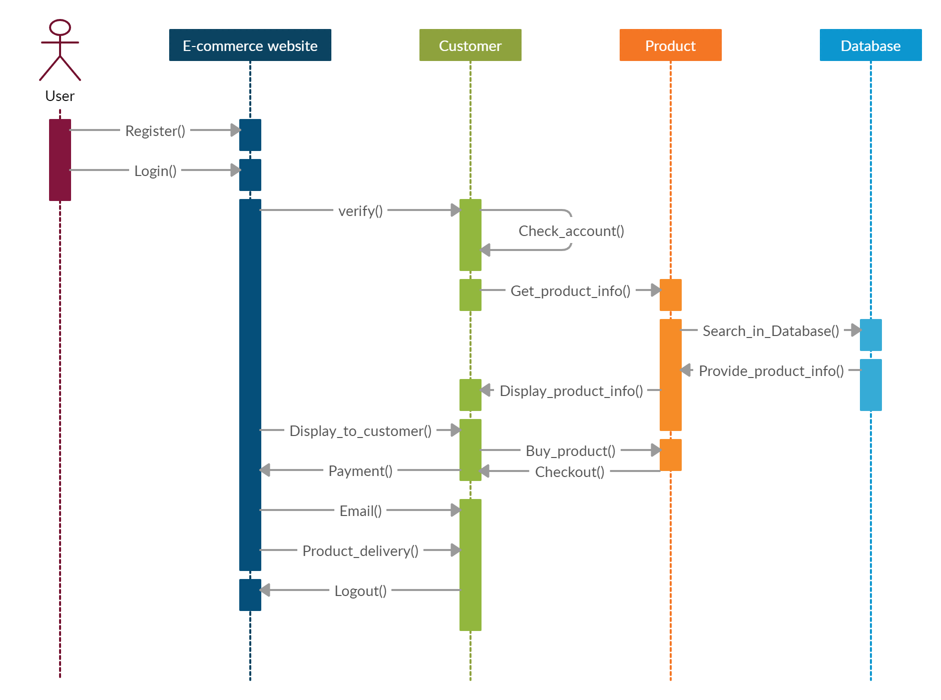

3.4 Activity Diagram

In the context of an e-commerce project, an activity diagram can be a valuable tool for modeling workflows and processes that customers, administrators, and other actors interact with. Here’s how you can approach creating an activity diagram for an e-commerce project

Client’s Settings are displayed

Invalid Email / password

No

Client’s Settings are displayed

Client successfully logs in

YES

Correct Email and password ?

Client enters Email and password

Client is registered

3.5 Data Dictionary

A data dictionary is an essential component of any software project, including an e-commerce project. It serves as a centralized repository of information about the data used in the system, including data types, relationships, constraints, and usage. The data dictionary provides a clear understanding of the structure and definition of data, making it easier to manage, maintain, and communicate data-related concepts within the project team.

* **Register Table:**

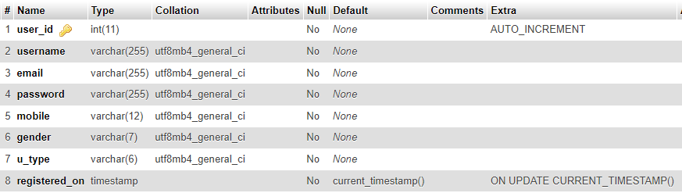

* **Address Table:**

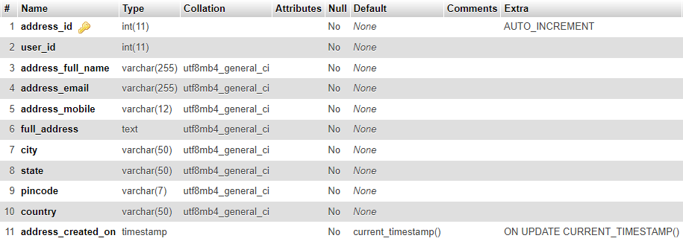

* **Brand Table:**

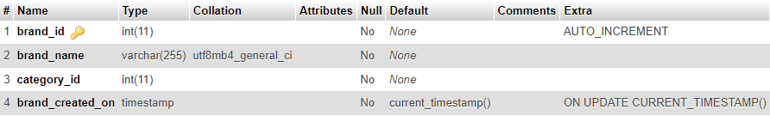

* **Category Table:**

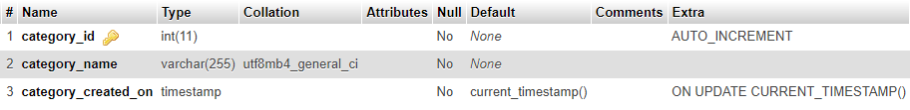

* **Product Table:**

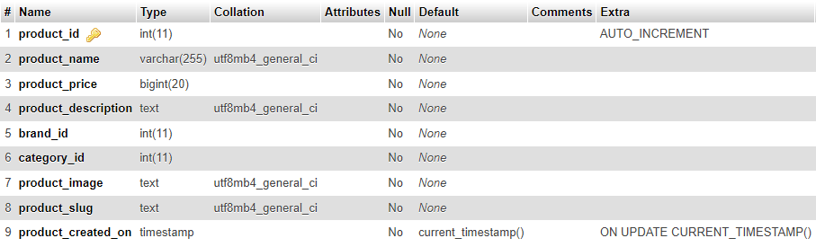

* **Cart Table:**

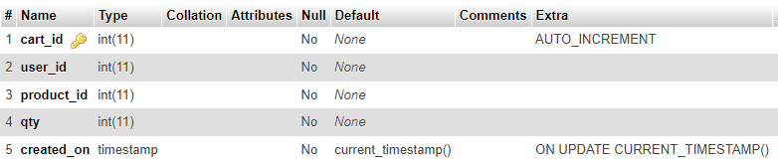

* **Contact us Table:**

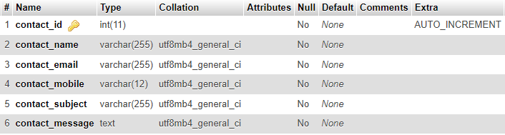

* **Order Table:**

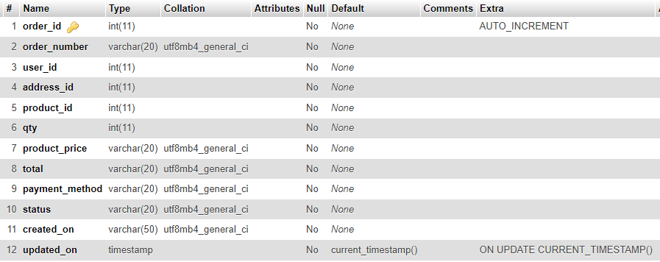

**Chapter – 4 Development**

4.1 Coding Standards

4.2 Screen Shots

4.1 Coding Standards

Coding standards are a set of best practices and guidelines for writing code in a consistent, maintainable, and efficient manner. For an e-commerce project, adhering to coding standards can help ensure that the codebase is clear, easy to understand, and of high quality. This is particularly important in an e-commerce project, where performance, security, and reliability are critical.

**Key Elements of Coding Standards for an E-commerce Project:**

1. **Naming Conventions:**

* **Variables:** Use clear, descriptive names that reflect the purpose or usage (e.g., orderId, productPrice).
* **Functions/Methods:** Name functions based on their purpose or action (e.g., calculateTotalPrice, getUserDetails).
* **Classes:** Use PascalCase for class names (e.g., ShoppingCart, CustomerProfile).
* **Constants:** Use uppercase with underscores for constants (e.g., MAX_ITEMS_PER_ORDER, TAX_RATE).

1. **Code Structure:**

* **Indentation:** Use consistent indentation (e.g., 2 or 4 spaces) to enhance readability.
* **Braces:** Place opening braces on the same line or the next line, depending on your language's style guide.
* **Line Length:** Keep line lengths within a reasonable limit (e.g., 80 or 120 characters) to improve readability.

1. **Comments and Documentation:**

* **Inline Comments:** Use comments to explain complex or non-obvious code.
* **Function Comments:** Provide comments for functions or methods explaining their purpose, inputs, and outputs.
* **Code Documentation:** Maintain comprehensive code documentation, including a README file, to guide developers.

1. **Error Handling:**

* **Exception Handling:** Use appropriate exception handling to manage errors gracefully.
* **Logging:** Implement logging to capture error information for debugging and auditing purposes.

1. **Security Best Practices:**

* **Input Validation:** Validate and sanitize user input to prevent attacks such as SQL injection and cross-site scripting (XSS).
* **Secure Coding:** Follow secure coding practices, such as using parameterized queries and secure communication channels.

1. **Performance Considerations:**

* **Optimization:** Optimize code for performance where necessary (e.g., database queries, loops, and algorithms).
* **Caching:** Use caching mechanisms to improve response times and reduce database load.

1. **Testing:**

* **Unit Testing:** Write unit tests for critical components to ensure their correctness.
* **Integration Testing:** Conduct integration tests to validate the interactions between different components.

1. **Version Control:**

* **Commit Messages:** Use clear and concise commit messages that describe changes.
* **Branch Naming:** Follow consistent naming conventions for branches (e.g., feature/login, bugfix/cart).

1. **Code Reviews:**

* **Peer Reviews:** Encourage peer reviews to identify issues, improve code quality, and share knowledge.

1. **File Organization:**

* **Folder Structure:** Organize files into a logical structure, such as separating frontend and backend code, or grouping files by feature or module.

Adhering to coding standards helps developers maintain a consistent codebase, which leads to fewer bugs, easier maintenance, and faster onboarding of new team members. In the context of an e-commerce project, it also contributes to the reliability and security of the platform, which is crucial for building trust with customers and ensuring smooth operation.

4.2 Screen Shots

* 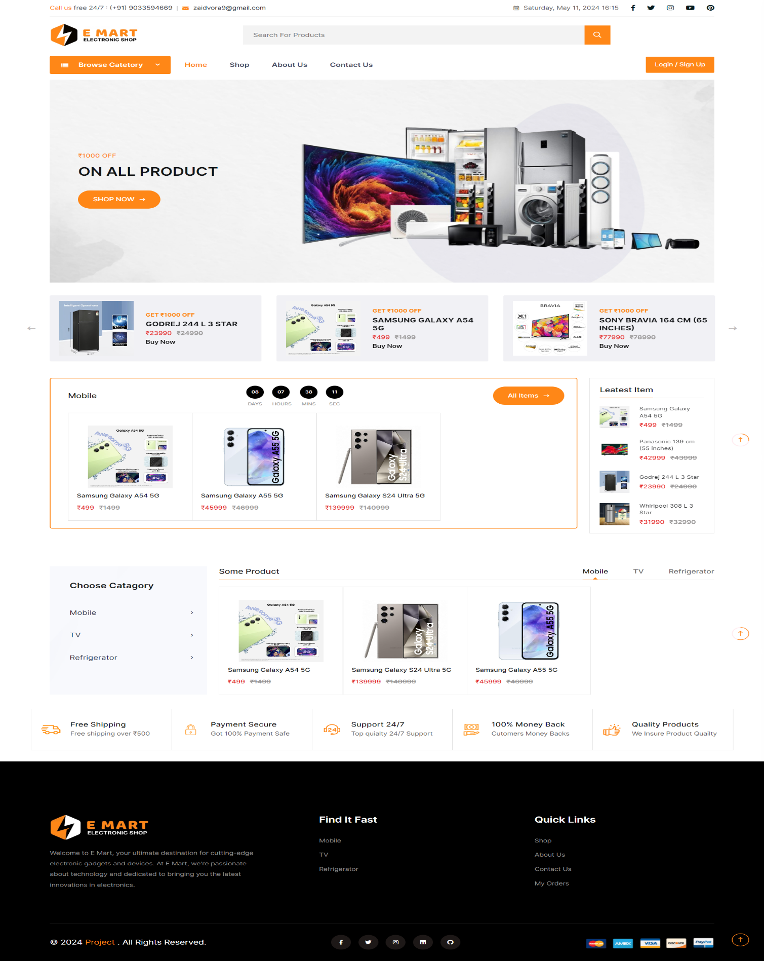**Homepage(index page) of E-Mart :**
* 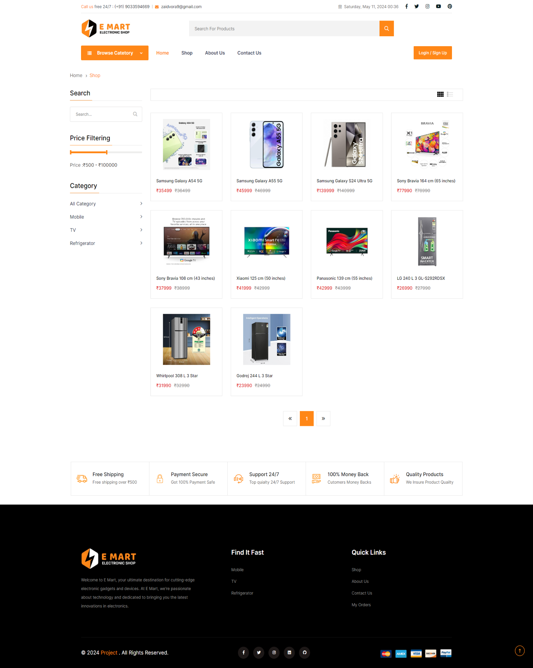**Shop page of E-Mart :**
* **About Us page of E-Mart :**

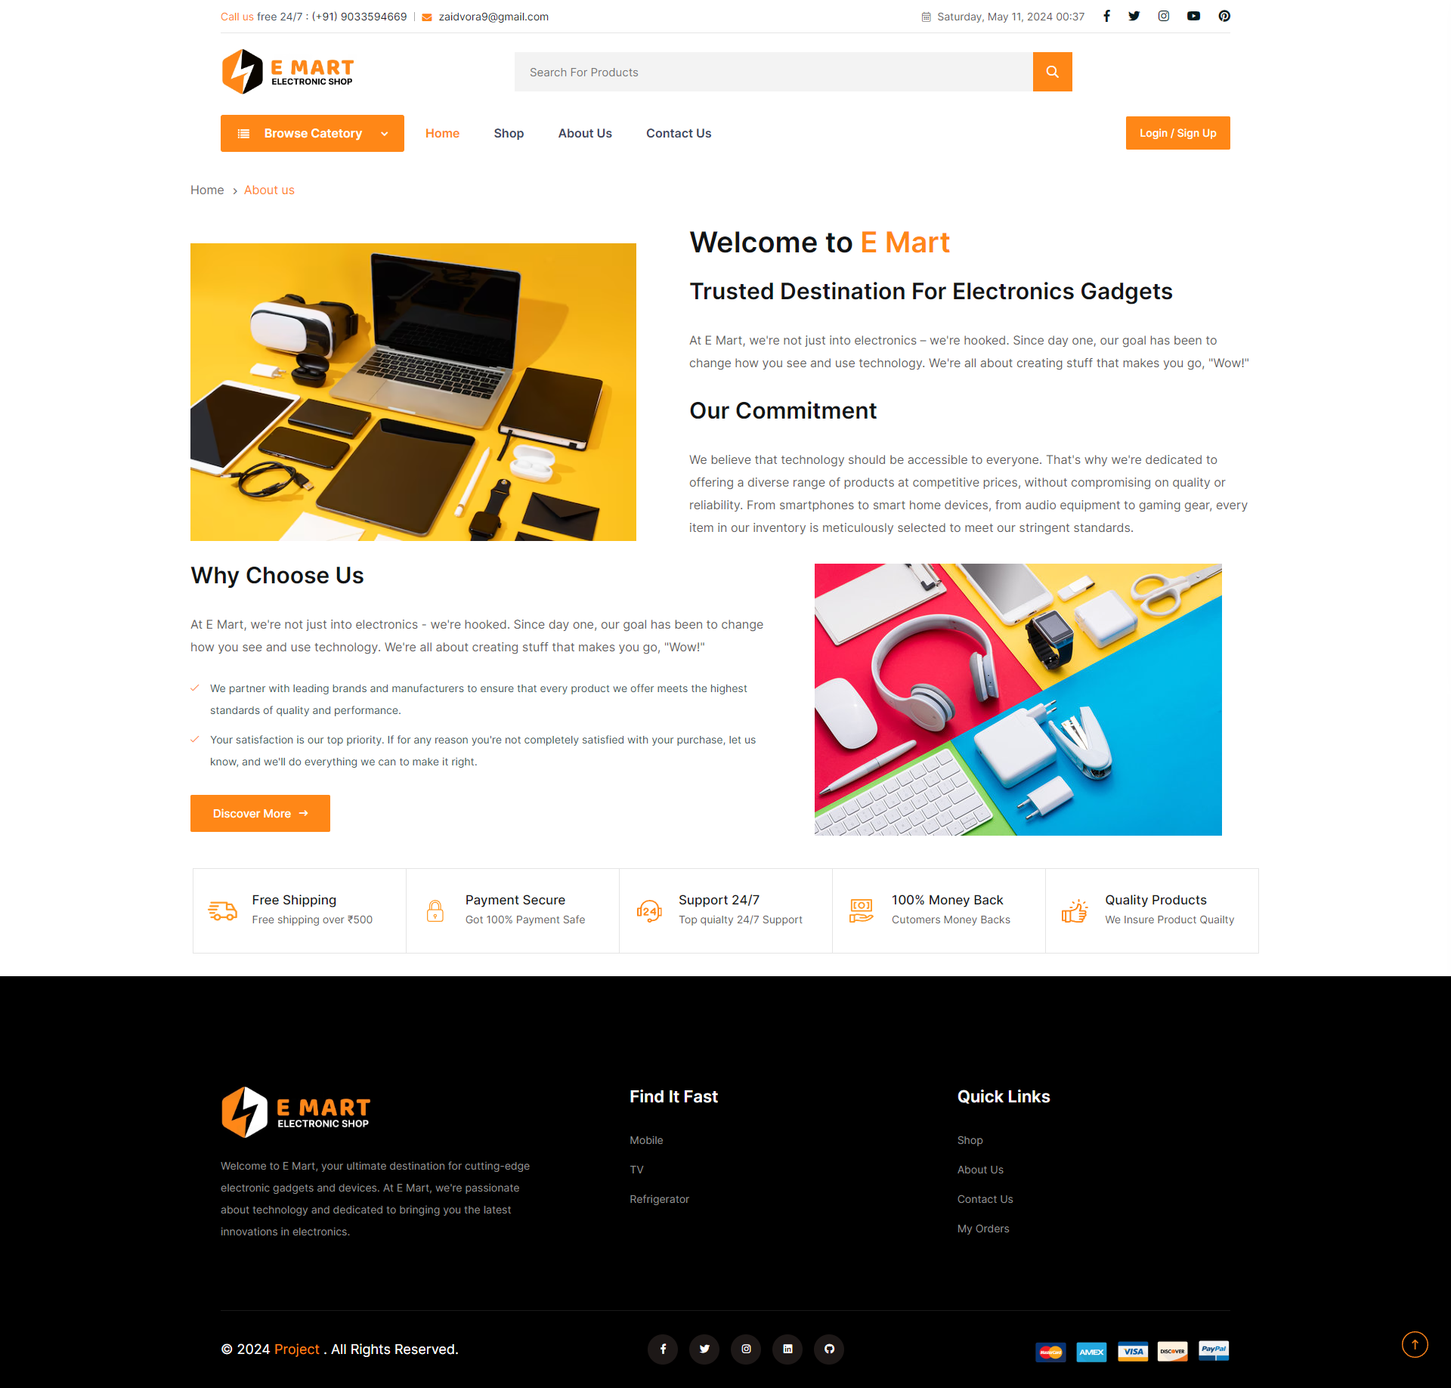

* 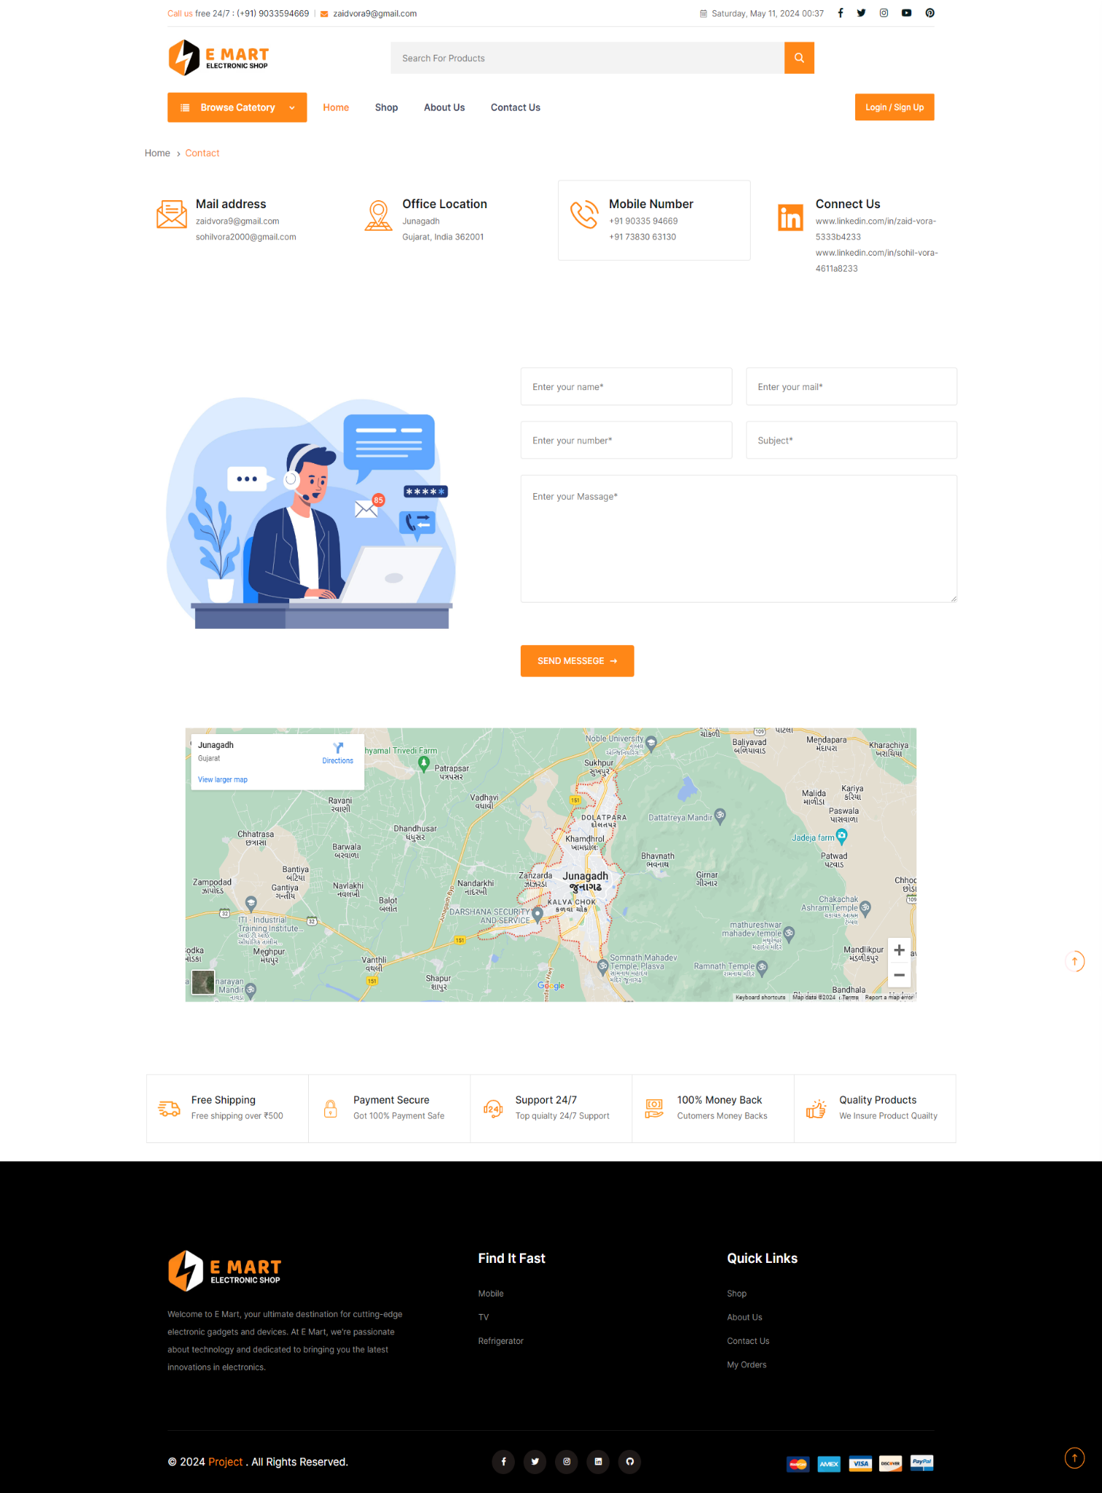**Contact Us page of E-Mart :**
* 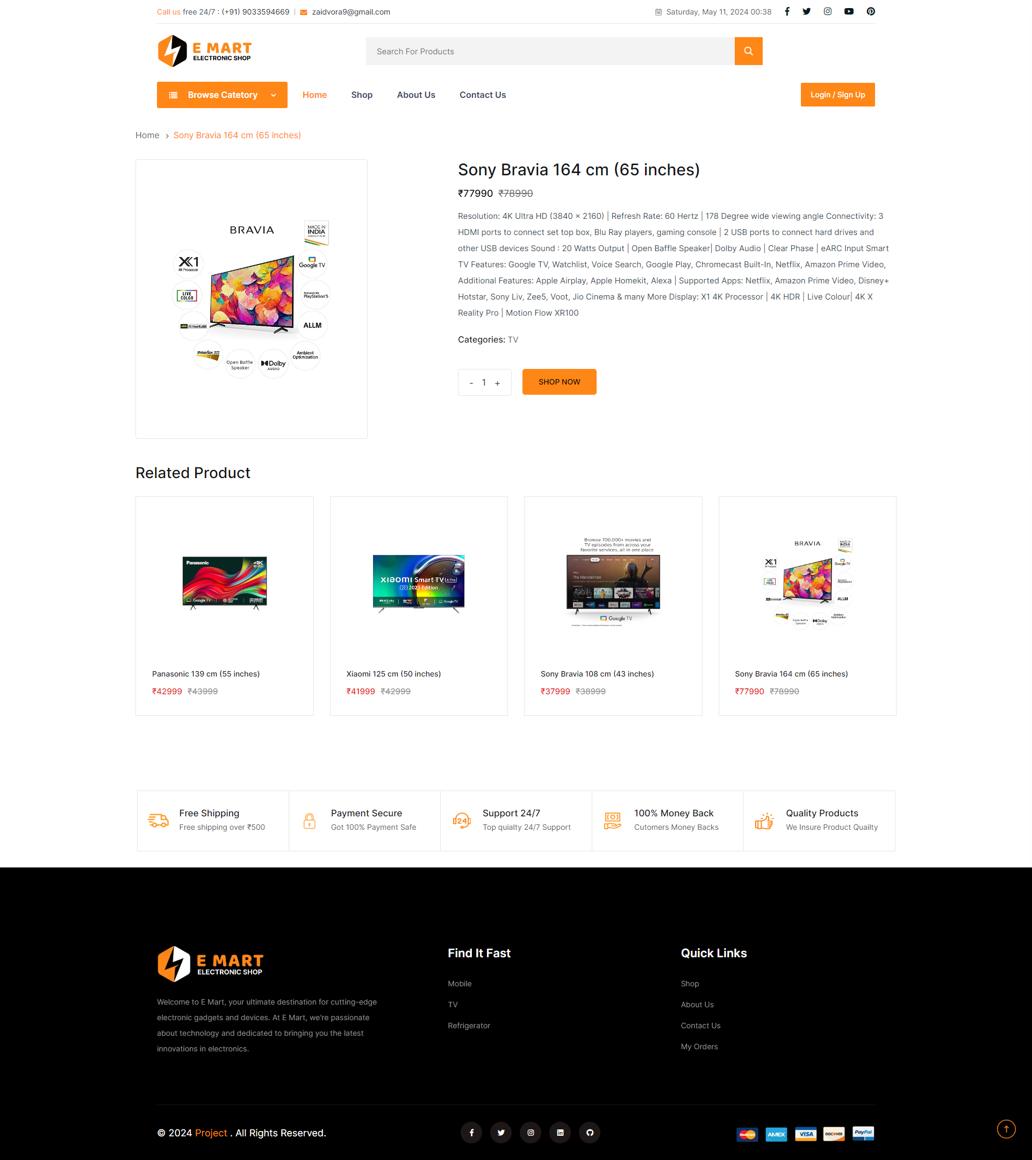**Product Details page of E-Mart :**
* **Login And Register page of E-Mart :**

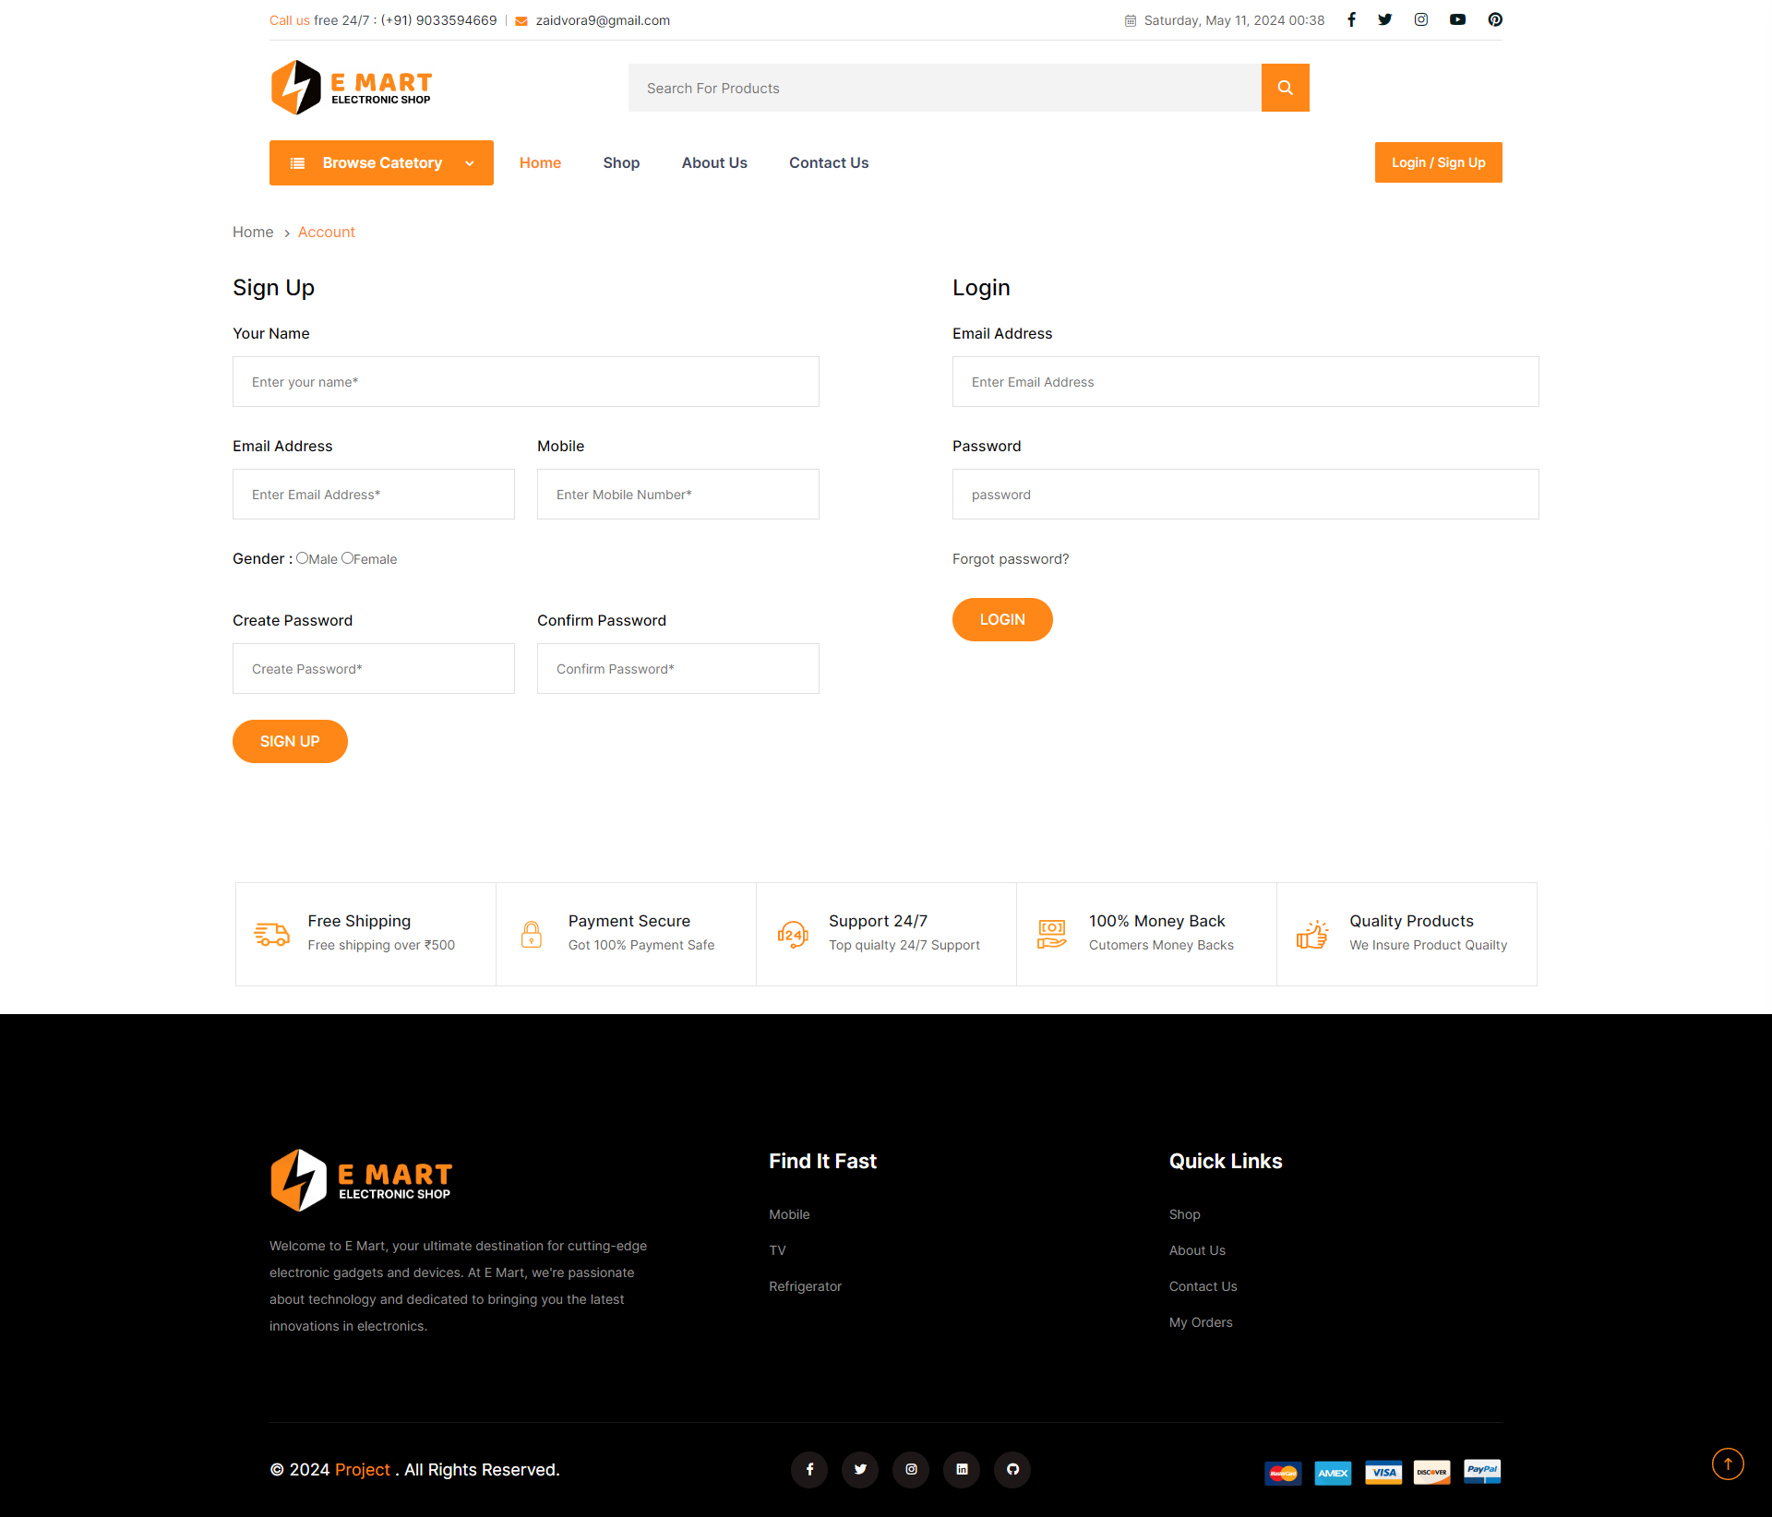

* **Cart page of E-Mart : User can add product to cart after Login.**

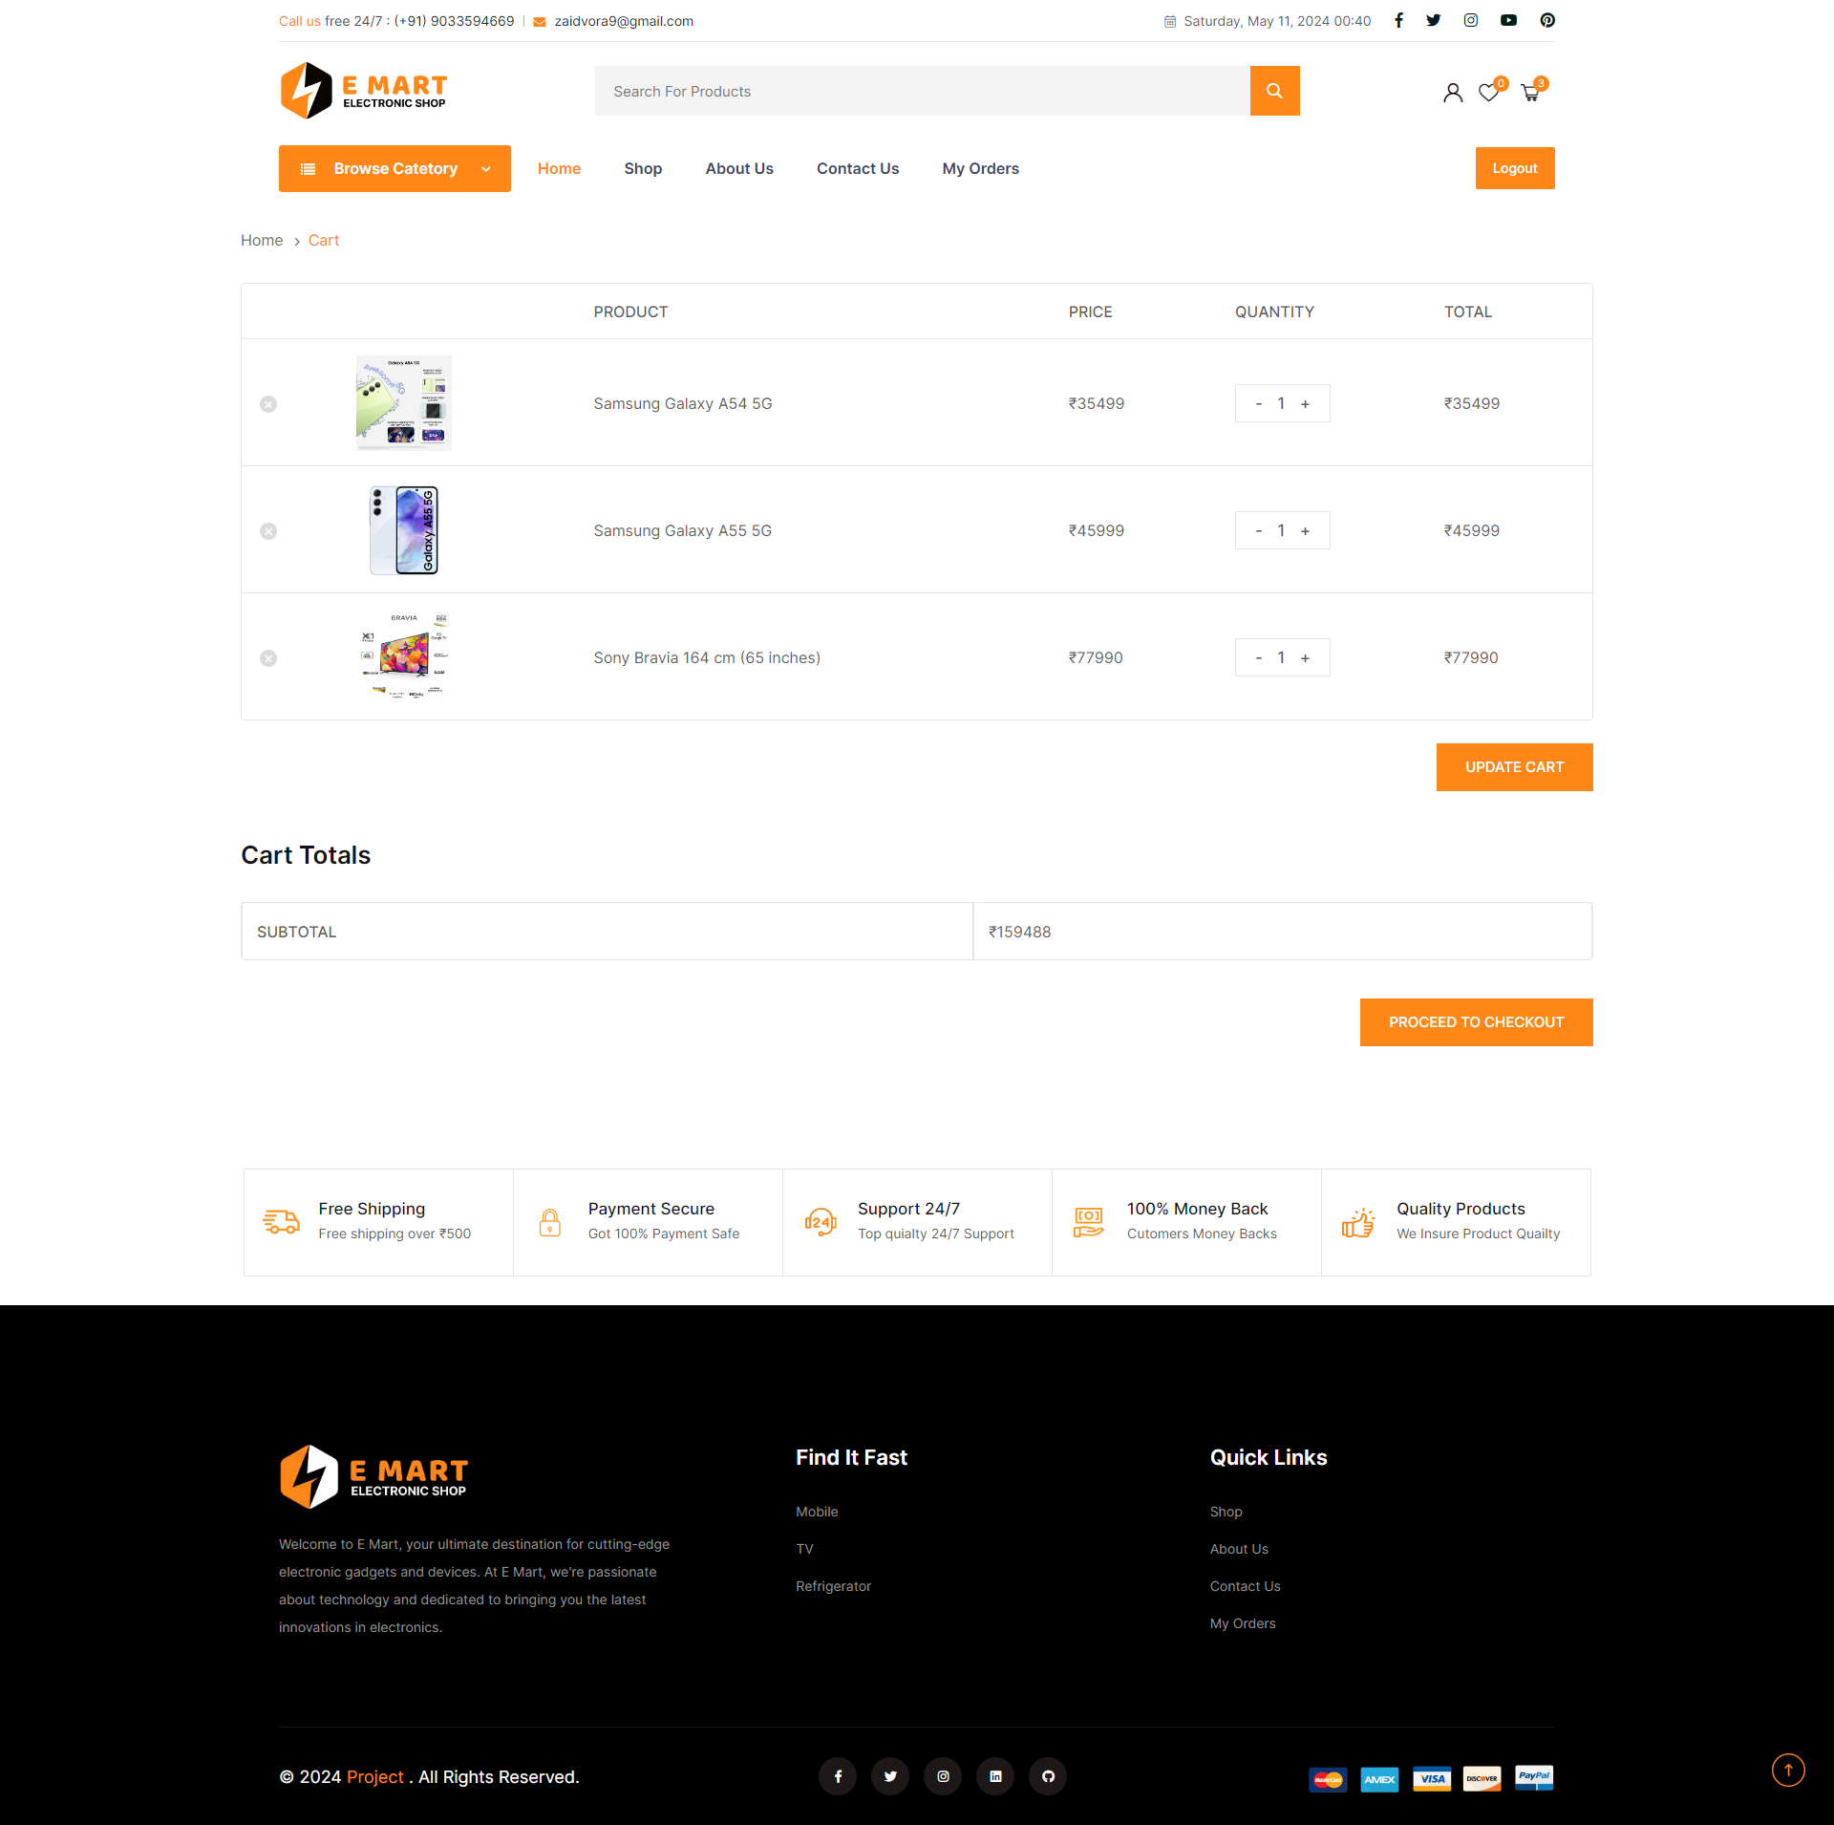

* **Checkout page of E-Mart : User can checkout product from cart after Login.**

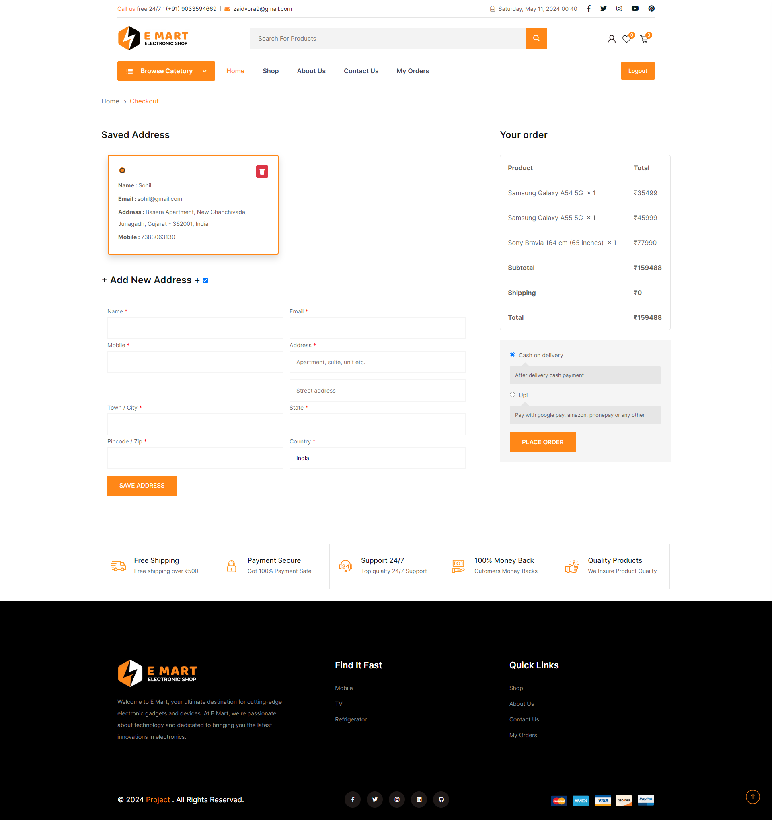

* **MyOrder page of E-Mart : User can check it’s order after Login.**

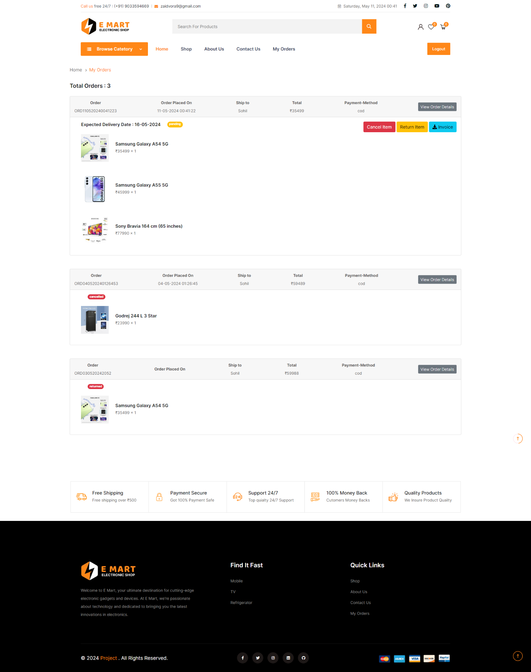

* **Invoice of E-Mart : User can download product Invoice from MyOrder after Login.**

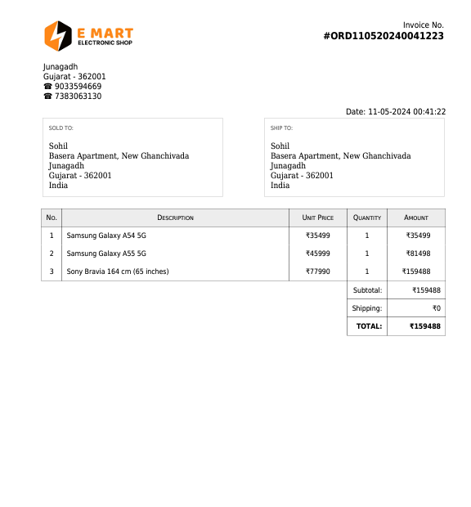

* 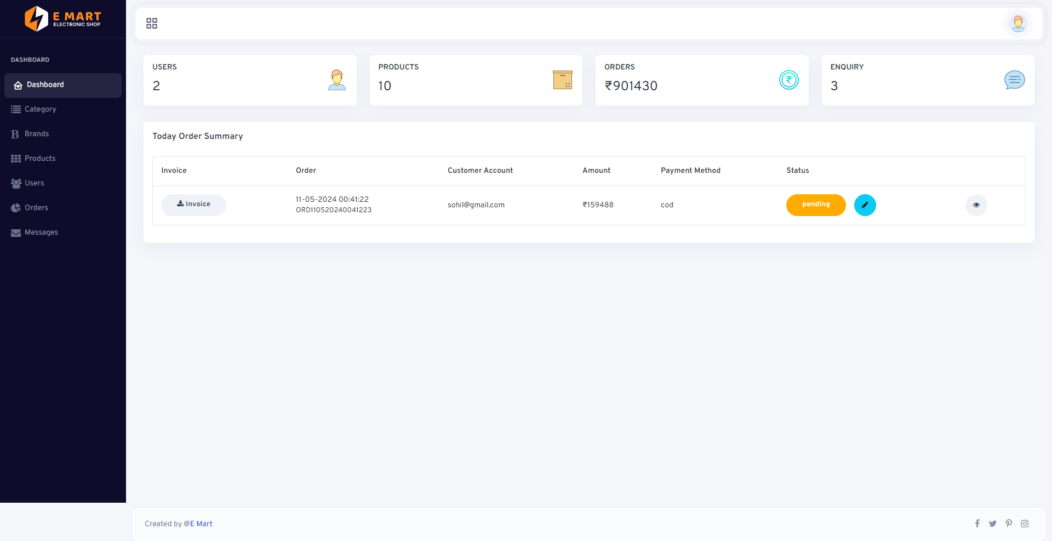**Homepage (Dashboard) of Admin Panel:**
* **Category Page of Admin Panel : Here Admin Can Add, Edit & Delete Category**

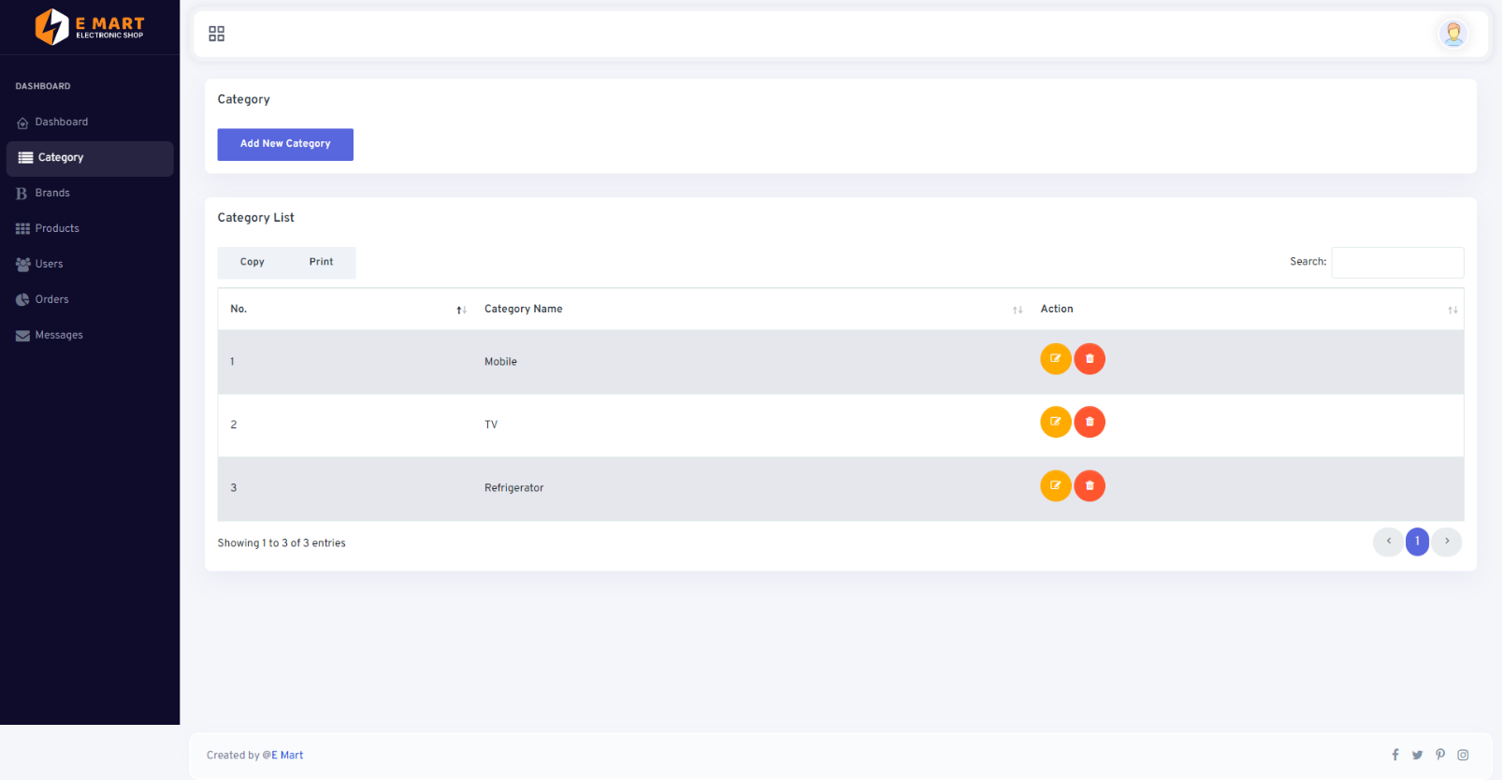

* 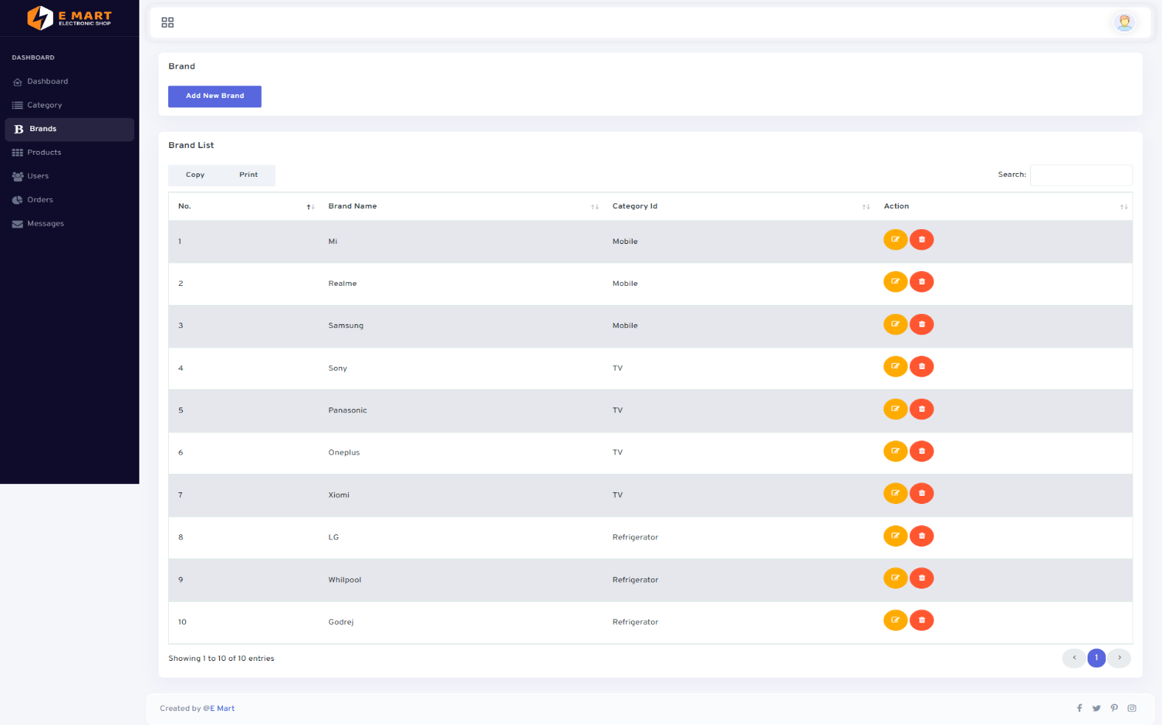**Brand of Admin Panel : Here Admin Can Add, Edit & Delete Brand**
* **Product Page of Admin Panel : Here Admin Can Add, Edit & Delete Product**
* 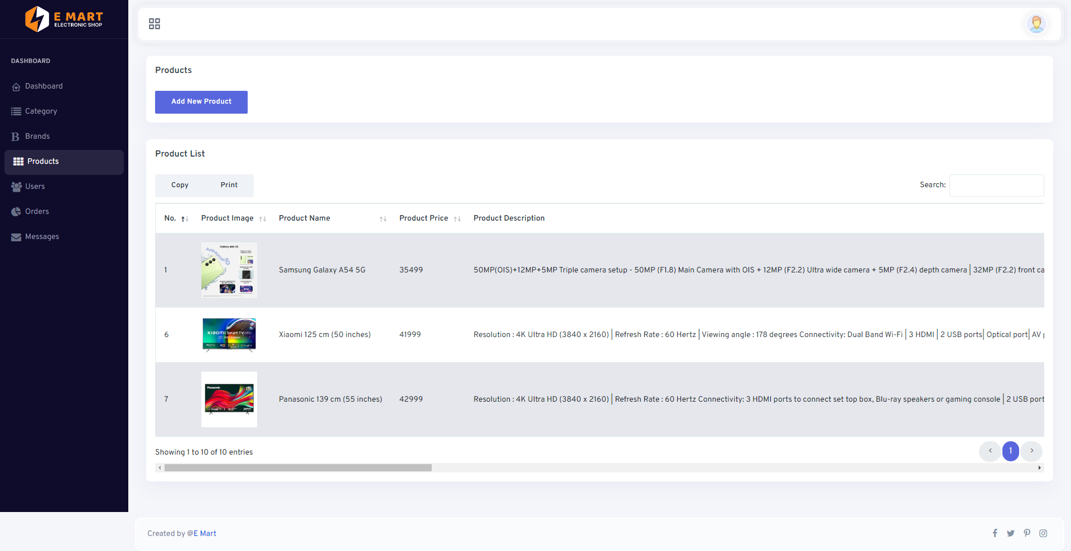**Order Page of Admin Panel : Here Admin Can Update & Cancel the order**

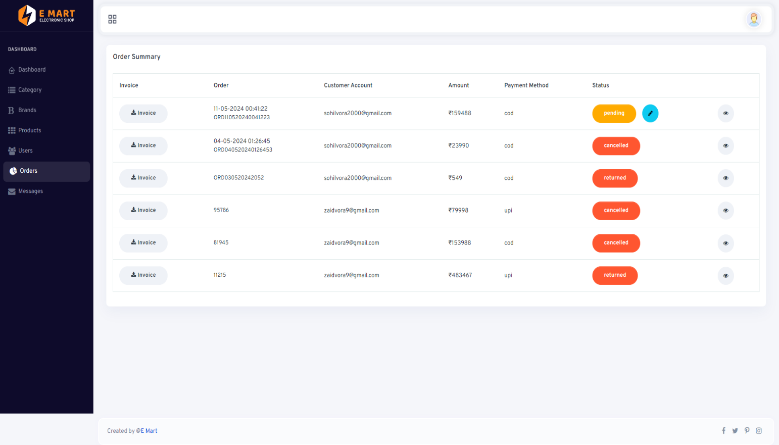

* **User Page of Admin Panel : Here Admin see howmany user’s are registered**

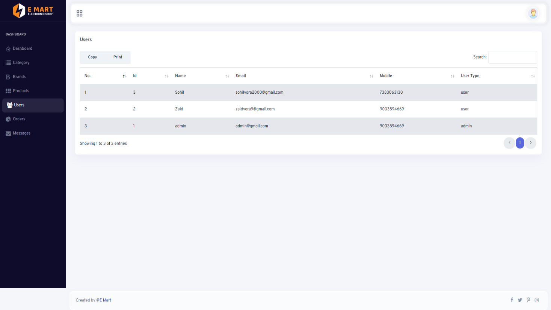

* **Message Page of Admin Panel : Here Admin see howmany user’s contact us**

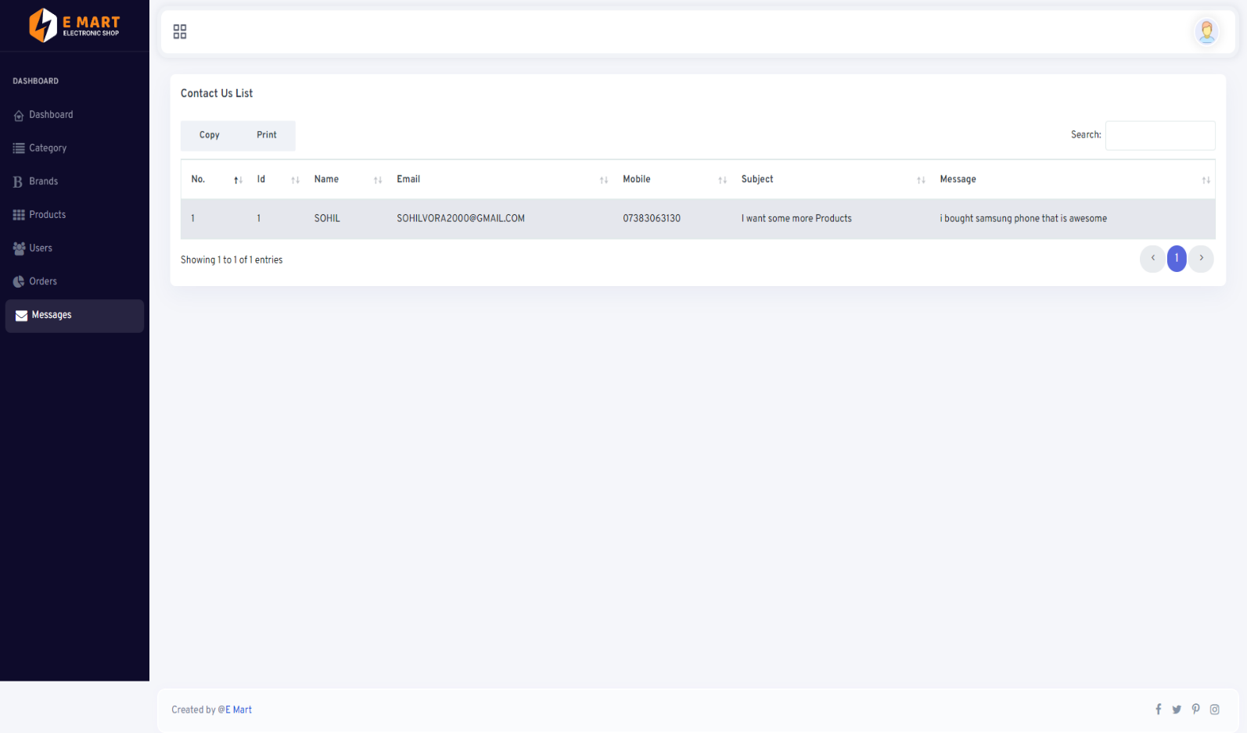

**Chapter – 5 Agile Documentation**

5.1 Agile Project Charter

5.2 Agile Roadmap / Schedule

5.3 Agile Project Plan

5.4 Agile User Story (Minimum 3 Tasks)

5.5 Agile Release Plan

5.6 Agile Sprint Backlog

5.7 Agile Test Plan

5.8 Earned-value and burn charts

5.1 Agile Project Charter

An Agile project charter serves as a foundational document that outlines the purpose, scope, objectives, and initial plan for an Agile project. While traditional project charters may be more detailed and rigid, Agile project charters are typically more lightweight and flexible, reflecting the iterative and adaptive nature of Agile methodologies like Scrum or Kanban. Here are key components typically found in an Agile project charter:

* **Project Vision:** A concise statement that communicates the overall purpose and desired outcome of the project. It sets the direction and aligns all team members towards a common goal.
* **Objectives and Key Results (OKRs):** Clear, measurable objectives that define what success looks like for the project. Key results provide specific, quantifiable targets to gauge progress towards each objective.
* **Scope:** Defines the boundaries of the project, including what will be delivered and what will not. It's important to keep the scope flexible to accommodate changes as the project progresses.
* **Stakeholders:** Identification of key stakeholders who have an interest or influence in the project. This includes both internal and external stakeholders such as sponsors, customers, users, and team members.
* **Roles and Responsibilities:** Clearly define the roles and responsibilities of each team member, including the product owner, Scrum Master (if using Scrum), developers, testers, and any other relevant roles.
* **Constraints and Assumptions:** Identify any constraints or limitations that may impact the project, such as budget, timeline, or resource availability. Also, list any assumptions made during project planning that need validation.
* **Milestones and Deliverables:** Outline major milestones and deliverables expected throughout the project lifecycle. These provide checkpoints for assessing progress and managing expectations.
* **Risks and Mitigation Strategies:** Identify potential risks that could impact the project's success and outline strategies to mitigate or respond to them.
* **Success Criteria:** Define the criteria that will be used to determine whether the project has achieved its objectives and delivered value to stakeholders.
* **Communication Plan:** Outline how communication will be managed within the project team and with stakeholders. This includes frequency, channels, and methods of communication.
* **Decision-Making Process:** Establish a clear process for making decisions within the project team, including how disagreements will be resolved and who has the authority to make final decisions.
* **Dependencies:** Identify any external dependencies that could impact the project schedule or deliverables, and develop strategies for managing them.

Agile project charters are living documents that may evolve over time as the project progresses and new information becomes available. They provide a framework for guiding the project while allowing for flexibility and adaptation to change.

5.2 Agile Roadmap/Schedule

Creating an Agile roadmap or schedule involves a dynamic and iterative process. Here's a general outline to help you get started:

* **Define Goals and Objectives:** Clearly articulate the overarching goals and objectives that the Agile roadmap will serve. These should align with the organization's strategic direction and business objectives.
* **Identify Epics:** Break down the goals into high-level initiatives or epics. These represent significant deliverables or outcomes that contribute to achieving the goals.
* **Prioritize Epics:** Prioritize the epics based on their importance and value to the business. Techniques like MoSCoW (Must have, Should have, Could have, Won't have) or Weighted Shortest Job First (WSJF) can be useful for prioritization.
* **Break Down Epics into User Stories:** For each epic, break it down into smaller, more manageable units called user stories. User stories represent specific features or functionalities from the user's perspective.
* **Estimate Effort:** Estimate the effort required for each user story. Techniques like Planning Poker or Relative Sizing can help the team in estimating effort more accurately.
* **Create Iteration Plan:** Plan the iterations or sprints based on the prioritized user stories. Typically, iterations are 1-4 weeks long, with a consistent duration throughout the project.
* **Define Sprint Goals:** For each iteration, define specific goals or objectives that the team aims to accomplish. These goals should align with the overall roadmap objectives.
* **Execute Iterations:** During each iteration, the team works on implementing, testing, and delivering the user stories committed to the sprint.
* **Review and Adapt:** At the end of each iteration, conduct a sprint review to demonstrate the completed work to stakeholders and gather feedback. Use this feedback to adapt the roadmap and prioritize future work.
* **Continuous Improvement:** Continuously refine and improve the Agile roadmap based on insights gained from each iteration and feedback from stakeholders. Adjust priorities and plans as necessary to maximize value delivery.

Remember, Agile is about flexibility and adaptability, so be prepared to adjust the roadmap and schedule as you learn more throughout the project.

5.3 Agile Project Plan

Creating an Agile project plan involves breaking down the project into smaller, manageable tasks and iterations. Here's a basic outline of what an Agile project plan might look like:

* **Project Vision and Objectives:**
* Define the overall vision and objectives of the project.
* Ensure alignment with stakeholders.
* **Product Backlog Creation:**
* Identify and list all features, enhancements, and tasks required to achieve the project objectives.
* Prioritize backlog items based on business value and dependencies.
* **Sprint Planning:**
* Select backlog items for the upcoming sprint based on priority and team capacity.
* Define sprint goals and success criteria.
* **Sprint Execution:**
* Daily Stand-up Meetings: Short daily meetings to discuss progress, challenges, and plans.
* Development: Team members work on assigned tasks collaboratively.
* Continuous Integration and Testing: Ensure regular integration of code and automated testing.
* **Sprint Review:**
* Demo the completed features to stakeholders.
* Collect feedback for future iterations.
* **Sprint Retrospective:**
* Reflect on the sprint process and identify areas for improvement.
* Discuss what went well, what could be improved, and action items for the next sprint.
* **Iterative Development:**
* Repeat steps 3 to 6 for subsequent sprints until project objectives are met.
* **Release Planning:**
* Plan releases based on the completion of specific features or milestones.
* Coordinate with stakeholders for release scheduling.
* **Monitoring and Adaptation:**
* Monitor project progress and key performance indicators (KPIs).
* Adapt the project plan based on feedback, changing requirements, and emerging risks.
* **Continuous Improvement:**
* Incorporate lessons learned from retrospectives into future sprints.
* Encourage a culture of continuous improvement within the team.

Remember, Agile is about flexibility and responding to change, so the plan should be adaptable to accommodate evolving requirements and priorities throughout the project lifecycle.

5.4 Agile User Story

A typical Agile user story follows a simple template:

"As a [role], I want [goal] so that [reason]."

Here's what each part represents:

* **As a [role]:** This describes the persona or user who will benefit from the feature being developed. It helps the team understand who the user is and what their needs might be.
* **I want [goal]:** This describes the specific functionality or feature that the user desires. It should be clear and actionable.
* **So that [reason]:** This explains the reason or benefit behind the desired functionality. Understanding the underlying motivation helps the team prioritize and make decisions during development.

**For example:**

"As a website visitor, I want to be able to filter search results by price so that I can quickly find products within my budget."

This user story identifies the role (website visitor), the desired functionality (filtering search results by price), and the reason (quickly finding products within budget).

User stories are typically written on index cards or in digital tools and are used to communicate requirements and priorities within Agile teams. They serve as a reminder that the focus should be on delivering value to the end user.

5.5 Agile Release Plan

An Agile release plan outlines the schedule for delivering increments of a product within an Agile development framework. Here's a step-by-step guide to creating one:

* **Product Vision and Roadmap:** Start with a clear understanding of the product vision and the high-level roadmap. What are the ultimate goals of the product, and what are the major features or functionalities needed to achieve those goals?
* **Backlog Refinement:** Break down the features or functionalities from the roadmap into smaller, actionable items known as user stories. These should be detailed enough for the development team to understand what needs to be done.
* **Prioritization:** Prioritize the user stories based on their importance and value to the end-users or stakeholders. This can be done collaboratively with the product owner and the development team.
* **Estimation:** Estimate the effort required to complete each user story. Techniques like story points or t-shirt sizing can be used for this purpose. The development team should provide these estimates based on their expertise and understanding of the tasks.
* **Release Planning Meeting:** Schedule a release planning meeting with the entire team, including the product owner, Scrum Master, and development team members. In this meeting, review the prioritized backlog and discuss which user stories can be included in the upcoming release based on their estimates and dependencies.
* **Capacity Planning:** Consider the team's velocity (the amount of work they can complete in a sprint) and the estimated effort of the user stories to determine how many stories can be included in the release. Ensure that the team has the capacity to deliver within the planned timeframe.
* **Create the Release Plan:** Based on the prioritized backlog, estimated effort, and team capacity, create a plan for which user stories will be included in each release. This plan should include the estimated release dates for each increment of the product.
* **Iterative Refinement:** Release plans in Agile are dynamic and subject to change based on feedback, new priorities, or changes in requirements. Continuously refine the plan as the project progresses, adapting to new information and insights.
* **Communication and Transparency:** Communicate the release plan to all stakeholders to ensure transparency and alignment. Regularly update stakeholders on the progress of the releases and any changes to the plan.
* **Execution and Monitoring:** Execute the releases according to the plan, monitoring progress along the way. Use metrics such as burn-down charts or cumulative flow diagrams to track progress and identify any potential issues early.

By following these steps, you can create an Agile release plan that allows for flexibility and adaptability while ensuring that the product is delivered incrementally, with value delivered to customers at each stage.

5.6 Agile Sprint Backlog

The Agile sprint backlog is a prioritized list of tasks or user stories that a development team plans to work on during a specific sprint in Agile methodology. It's a crucial artifact in Scrum, a popular Agile framework, though it's utilized in other Agile methodologies as well.

Here's how it typically works:

* **Product Backlog Refinement:** Before the start of a sprint, the product owner, with input from the team, refines the product backlog, ensuring that the top items are well-defined and ready to be worked on.
* **Sprint Planning:** During sprint planning, which usually occurs at the beginning of a sprint, the team selects a set of items from the product backlog to work on. These items are based on priority, team capacity, and sprint goals. The selected items are then moved from the product backlog to the sprint backlog.
* **Sprint Backlog:** The sprint backlog is a subset of the product backlog and contains the tasks or user stories that the team commits to completing during the sprint. It's a living document that evolves as the sprint progresses. Tasks in the sprint backlog are broken down into smaller, actionable items and estimated for effort.
* **Daily Standups:** Throughout the sprint, the team meets daily for a brief standup meeting where they discuss progress, any impediments, and adjust their plan as necessary. The sprint backlog serves as a reference point during these meetings.
* **Completion and Review:** At the end of the sprint, the team presents the completed work during the sprint review meeting. Any unfinished tasks are either returned to the product backlog for future consideration or included in the next sprint backlog.

By maintaining a sprint backlog, teams can focus on delivering a set of features or improvements within a short, fixed timeframe while remaining adaptable to changes and feedback.

5.7 Agile Test Plan

An Agile test plan outlines the testing activities to be conducted within an Agile development framework. Unlike traditional test plans, Agile test plans are more dynamic and flexible to accommodate the iterative nature of Agile development. Here's a typical structure for an Agile test plan:

* **Introduction:** Briefly introduce the purpose and scope of the test plan, including the project background and objectives.
* **Testing Objectives:** Define the specific goals and objectives of testing within the Agile project. This could include ensuring product quality, verifying user stories, and identifying defects early.
* **Testing Scope:** Clearly define what will and won't be tested. This includes the features, functions, platforms, and environments covered by testing.
* **Testing Strategy:** Outline the overall approach to testing within the Agile framework. This may include strategies for test automation, exploratory testing, continuous integration, and continuous delivery.
* **Test Team Roles and Responsibilities:** Specify the roles and responsibilities of team members involved in testing, including testers, developers, product owners, and any other stakeholders.
* **Test Deliverables:** List the testing artifacts to be produced during the project, such as test cases, test scripts, test data, and test reports.
* **Testing Tools:** Identify the tools and technologies to be used for test management, automation, defect tracking, and collaboration.
* **Testing Timeline:** Provide a high-level timeline for testing activities, including sprint-wise testing goals and milestones.
* **Risks and Mitigation Strategies:** Identify potential risks and challenges related to testing in an Agile environment, along with strategies for mitigating these risks.
* **Communication Plan:** Describe how communication will be managed among team members, including regular meetings, status reports, and collaboration tools.
* **Change Management:** Define how changes to the test plan will be handled throughout the project, considering the iterative nature of Agile development.
* **Approval and Sign-off:** Specify the process for obtaining approval and sign-off on the test plan from relevant stakeholders.

It's important to remember that Agile test plans should be adaptable and evolve throughout the project as requirements change and new information emerges. Regular review and refinement of the test plan are essential to ensure alignment with project goals and objectives.

5.8 earned-value & burn Chart

In Agile project management, earned value and burn charts are not as commonly used as in traditional project management methodologies like Waterfall. However, they can still be adapted to Agile practices.

1. **Earned Value (EV) in Agile:** In Agile, earned value can be interpreted as the value of the work completed by the team in a given iteration or sprint. This can be measured in story points completed, features implemented, or any other unit of value agreed upon by the team. EV gives insight into how much value has been delivered compared to the planned work.
2. **Burn Chart:** A burn chart is a graphical representation of work completed (or burned down) over time. In Agile, it's typically used to visualize the progress of the team in completing the items from the backlog (often user stories or tasks) within a sprint or iteration. The horizontal axis represents time (usually in iterations or sprints), while the vertical axis represents the amount of work remaining. As the team completes tasks, the burn chart line moves downwards, ideally reaching zero by the end of the sprint.

Here’s how you can integrate Earned Value and Burn Charts in Agile:

* **Earned Value Calculation:** At the end of each iteration or sprint, calculate the earned value by summing up the story points or other units of value completed by the team.
* **Planned Value (PV):** Planned value in Agile can be represented by the total estimated story points or value points planned for the iteration.
* **Actual Cost (AC):** Actual cost might be more straightforward in Agile, as it could represent the actual time or resources spent on completing the tasks.
* **Burn Chart:** Plot the burn chart using the remaining work (in story points or tasks) on the vertical axis and time (iterations or sprints) on the horizontal axis. Update the chart daily or at the end of each iteration.
* **Comparison:** You can compare the planned value, earned value, and actual cost to get insights into the project's progress, efficiency, and potential issues.

**Chapter – 6 Proposed Enhancements**

Enhancing an eCommerce website involves improving various aspects such as user experience, functionality, design, and performance. Here are some proposed enhancements:

* **Mobile Optimization:** Ensure the website is fully responsive and optimized for mobile devices. More and more users are shopping on smartphones and tablets, so a seamless mobile experience is crucial.
* **Improved Navigation:** Simplify navigation by reorganizing categories and subcategories, making it easier for users to find products. Implement features like predictive search, filters, and sorting options to enhance user experience.
* **Streamlined Checkout Process:** Reduce cart abandonment rates by optimizing the checkout process. Implement a single-page checkout, guest checkout option, and multiple payment gateways to make the process fast, easy, and secure.
* **Personalized Product Recommendations:** Utilize algorithms to offer personalized product recommendations based on users' browsing and purchase history. This can enhance engagement and increase sales by suggesting relevant products.
* **Enhanced Product Imagery and Videos:** Improve product pages with high-quality images and videos that provide multiple angles, zoom functionality, and demonstration videos. This helps users make informed purchasing decisions.
* **Integration with Social Media:** Allow users to share products on social media platforms and incorporate social proof elements like user reviews and ratings. Integration with social media can also facilitate social login for easier account creation and login.
* **Optimized Search Functionality:**  Enhance the search functionality by implementing autocomplete suggestions, spell check, synonyms, and advanced search filters. This helps users quickly find what they're looking for, increasing conversion rates.
* **Implement Live Chat Support:** Offer real-time assistance to customers through live chat support. This can help address customer queries, provide product recommendations, and resolve issues, leading to improved customer satisfaction and loyalty.
* **Optimization for Speed and Performance:** Ensure fast loading times and smooth performance across all devices. Optimize images, minify code, leverage caching, and utilize content delivery networks (CDNs) to improve website speed.
* **Integration with CRM and Marketing Automation:** Integrate the eCommerce platform with customer relationship management (CRM) software and marketing automation tools to streamline customer communication, segment audiences, and personalize marketing campaigns.
* **User Account Customization:** Allow users to customize their accounts by saving favorite products, creating wish lists, setting up alerts for price drops or restocks, and managing their orders and returns more efficiently.
* **Real-Time Inventory Management:** Implement real-time inventory management to provide accurate stock availability information to customers. Prevent overselling and backorders by syncing inventory levels across all sales channels.
* **AI-Powered Chatbots:** Integrate AI-powered chatbots to provide instant customer support, answer common questions, and assist with product recommendations. Improve customer service efficiency and accessibility.

Enhanced Security Measures: Implement robust security measures to protect customer data and secure online transactions. Use SSL certificates, encryption, and PCI compliance to ensure a safe shopping environment.

**Chapter – 7 Conclusion**

In conclusion, the success of an eCommerce website hinges on its ability to provide a seamless and satisfying shopping experience for customers. By implementing a range of enhancements such as personalized recommendations, streamlined checkout processes, and responsive customer support, businesses can foster trust, loyalty, and ultimately drive sales.

Moreover, staying ahead in the eCommerce landscape requires adaptability to emerging trends and technologies. Features like visual search, social commerce integration, and subscription services not only cater to evolving consumer preferences but also differentiate the website from competitors.

Additionally, optimizing the website for mobile devices, streamlining the checkout process, and offering subscription services can further enhance convenience and accessibility for users. Localization, visual search capabilities, and responsive design ensure that the website caters to a diverse audience and provides a seamless shopping experience across different devices and regions.

In essence, a well-enhanced eCommerce website prioritizes user convenience, reliability, and innovation. By continually refining the user experience and leveraging the latest tools and strategies, businesses can position themselves for sustained growth and success in the dynamic world of online retail.

To remain successful in the highly competitive eCommerce landscape, it's important for businesses to continually innovate and adapt to emerging trends and technologies. By prioritizing customer satisfaction, embracing new opportunities for engagement, and staying responsive to feedback, eCommerce websites can achieve sustained growth and success in the digital marketplace.

Ultimately, a well-enhanced eCommerce website not only attracts more visitors but also converts them into loyal customers. Continuously refining and innovating the website's features and functionality will enable businesses to stay ahead of the curve and meet the evolving needs of online shoppers.

**Chapter – 8 Bibliography**

For the successful working of my project I have referred many sources for the code snippets, logic and tips and tricks from the various books as well as web sites. Most I searched for the required possessions on the google.com search engine.

* **PHP:**
* Author Name: MERCER, DAVE W. & OTHER.
* Publication Name: PHI Publication.
* PHP Manual Download Link:-<http://www.php.net/docs.php>
* **MySQL:**
* Author Name: - 1) SHELDON ROBERT

2) MOES, GEOFF.

* **Web Link:**
* www.google.com
* [www.w3schools.com](http://www.w3schools.com)
* <https://getbootstrap.com/docs/4.6/getting-started/introduction/>

